**NEWSLETTER**

Volume 21 Issue 04 April 2025

| **Guild Meeting:**  April 10th, 6pm  May 8th, 6pm  ~At Ascend Services  2818 Meadow Lane, MTWC | **Upcoming:**  **Quilt Show Wrap Up Meeting**  April 24, 5:30pm at Port Sandy Bay  Details below  **English Paper Piecing Workshop**  May 10, Details on page 2 |
| --- | --- |
| **Mystery Quilt - Page 7** | |

| **From the President’s Desk** |
| --- |

Hi everyone! By the time you receive this, all the hard work and preparation for the POLQ show will probably be over, and we should be basking in happy memories. I’ve talked to one member who is already starting on a quilt for next time…or maybe it’s just she didn’t have enough time to finish for this year. Well, who needs an excuse to start on a new quilt? Maybe you can make a block for the county fair (pink, royal blue and black with a “rock and roll” theme if my notes are correct). Or maybe you’d like to jump on this year’s mystery quilt. Look on our website for the directions in each newsletter starting with September.

Our May meeting will be May 8, with the English Paper Piecing Workshop on May 10. Please see details elsewhere in this newsletter.

I so enjoy being friends with all of you and sharing my love of quilting.

~Ellen Lewellen

| **Quilt Show Wrap Up Meeting** |
| --- |

I hope that you will be able to make it to our wrap up meeting on Thursday, April 24th, at 5:30pm at Port Sandy Bay (6421 County Rd O, Two Rivers). Food is on your own.

Please bring your committee folder along with any comments or suggestions from the quilt show. If unable to make it, please get your folder to Kathy or I as soon as possible.

~Julie Klumpp

| **English Paper Piecing Workshop** |
| --- |

May 10, 8am at Ascend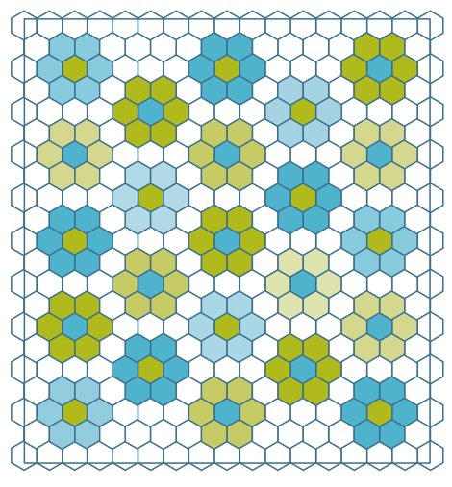

Cost is $13 to cover hall rental and some supplies

Supply list below

Contact Rosalie Miller or Ellen Lewellen to sign up

***What is English Paper Piecing and How is it Different from Regular Paper Piecing?***

English Paper Piecing is primarily hand sewing. It uses a technique of wrapping fabric scraps around a precut stiff piece of paper, then sewing those fabric wrapped paper pieces together. Regular paper piecing or Foundation paper piecing uses a larger piece of paper with the pattern printed on it, usually with each piece to be added in a numbered order on the reverse side of the pattern. One thing both techniques have in common is removing the papers before adding a backing and quilting the piece.

***Why would you want to learn this technique?***  It’s fun! It can use scraps from your stash! It’s portable….handwork easily brought along while you’re waiting at the doctor’s office, on a car trip, at your in-laws…..! C’mon, this is something you know you always wanted to try! And it’s pretty easy…you can teach it to your 8 year old.

We will be starting out with one of the easiest shapes to master…the hexagon, although other shapes will be demonstrated. If you’d like to try your hand at fussy cutting, choose one of your fabrics with a repeating motif and plan on using more fabric. Other than the paper pieces themselves, which I will provide, the supplies you need to bring are simple.

Supplies List

* 3 different pieces of fabric, pressed. Approx 4”, then 1/8 yd and 1/4 yd.
* Sharp fabric shears and hand sewing scissors or snips
* A thin needle and thread to blend with your fabric, 50 weight thread preferred but not a deal breaker
* Thimble if you use one
* Optional: small cutting mat or rotary mat with cutter. I use my shears myself, but I’ll show you this method if you prefer
* 1 light, 1 dark marking pencil or pen depending on your fabric
* 2 or 3 binding clips, optional
* 1 gal zipper top bag to keep everything in

| **~ March 13th Guild Meeting Minutes ~** |
| --- |

* **Call to Order**
  + Welcome Guest & Pledge
* **Business Meeting**
  + National Quilting Day
    - Open Sew March 15 & 16, 9-3 at Ascend
    - Special Demos / Make & Takes throughout the day on March 15
  + Camp Quilt
    - March 21-23
  + Secretary and Treasurer’s Report
    - Motion to accept Tina Waack 2nd Lori Hansen-Stein carried
  + Workshop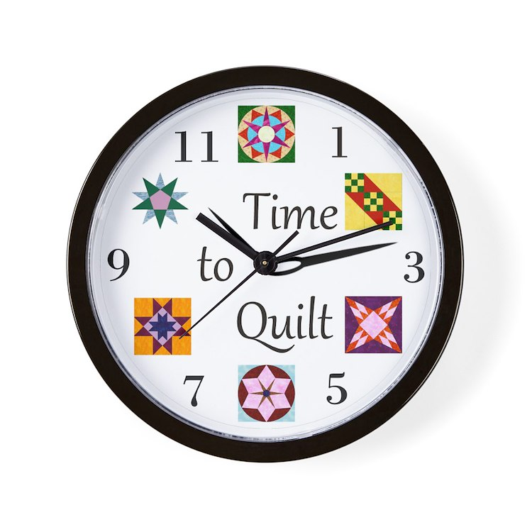
    - English Paper Piecing by Ellen Lewellen
    - May 10, 8am-4pm at Ascend
    - Cost is $10, BYO Lunch
    - Supply list to be announced at later time
* **Show & Tell**
* **Snacks**
* **Program : Quilt Show** presented by Kathy G and Julie K
  + *217 Total Quilts*
    - 38 judged, 21 for Veterans, 13 challenge
  + Committees: Let Kathy/Julie know how many tables and chairs you need at the show
  + *Set Up*
    - Tues, April 1: Marking layout around 1pm
    - Wed, April 2:
      * 8:15am - 97.1FM WCUB interview about the Guild and Quilt Show
      * 8:30am-Noon continued set up of lights, poles, curtains
      * 9-11am Judged Quilts to be delivered
      * 1pm Judging begins, no set up during this time
      * Set up resumes after judging complete?
    - Thurs, April 3:
      * Set Up continues through out the day
        + Bring a ladder and an able bodied ladder climber if possible
      * 9am-6pm: deliver quilts
      * Food and charity donations drop off through day
      * 12noon - 6:30pm: Gift Boutique drop off
    - Fri, April 4: Set Up Continues
      * 9am to Noon Gift Boutique drop off
      * 2pm Vendors start setup

| **~ March 13th Guild Meeting Minutes ~ continued** |
| --- |

* + - Sat, April 5:
      * Show Open 9am to 3pm, doors will be open early for volunteers
    - Sun, April 6:
      * Show Open 9am to 3pm, doors will be open early for volunteers
      * 1pm Quilts for Veterans presentation
      * 3pm: Raffle Quilt Drawing
      * 3pm: Help Vendors as needed
      * Once all vendors are done, take down show
        + No quilts are released until EVERYTHING is taken down
  + *Cash / Square Account*
    - Attendees will be able to use their credit/debit cards for admission and the gift boutique
    - If you know how to use the square, let Julie or Kathy know
  + *Charity Booth*
    - Price your donation please!
  + *Gift Boutique*
    - Needed: Gift bags, any size and any season
    - Number all your items consecutively
    - Maximum 12 of one type of item out at a time
      * You may have extras stored under the table. Sold items can be restocked through out the show
  + *Veterans Quilt*
    - Vets receiving a quilt get a free admission ticket - See Julie K for ticket
      * If you want to purchase an extra ticket/s, ie for spouse/family member of vet, that can be purchased from Julie K
    - Vets quilts will be taken down on Sunday starting at 12noon for the 1pm presentation
    - Giving a quilt to a vet? Write up a one paragraph bio and give a copy to Nan Groll
  + *Sat & Sun Food*
    - If you are signed up to bring a dessert:
      * Bring on Friday in a disposable pan/tray
      * Do NOT cut your dessert
  + *Work Schedule*
    - See Ellen Lewellen if you still need to sign up…or forgot what/when you signed up for.

| **~ March 13th Guild Meeting Minutes ~ continued** |
| --- |

* + *Quilt Walk* (quilts displayed in local businesses for show publicity)
    - Check out these stores (maybe give them a little business or nice compliment) that are displaying quilts:
      * Library (Manitowoc and Two Rivers), Basil Sustainable, Pink Petal, Visit Manitowoc, Heart & Homestead
        + (possibly others, this is all I know of at the moment)
  + *Storage Shed*
    - NEED SOMETHING FROM THE SHED???
    - Contact Jeanette Wiesner to have items brought to the expo
      * Be as specific as possible
  + *Traveling Sharpener*
    - Don't just bring your scissors! She can sharpen all your kitchen knives, yard shears, mower blades, and more!
  + *Vendors*
    - Please shop our vendors!
      * We want to encourage them and have them be eager to come again for the next show!
  + *Guild Membership*
    - Invite your friends!
    - Membership forms will be available at the show at the admissions table
  + *Sparks Quilt*
    - Did you help make a quilt with the SPARKS program?
    - Looking for who made a quilt for Tom
      * Contact ….. (I [Naomi] can't remember if it was Winnie K or Mary H who was asking about this???)
* Questions about the Quilt Show???
  + Contact: Kathy G : Kguralski@ymail.com  
     or Julie K : [jaklumpp@tm.net](mailto:jaklumpp@tm.net)
* Motion to Adjourn: Kathy Guralsko 2nd: Ann Hall carried

Submitted Naomi Anderson

| **Lost and Found** |
| --- |



Does anyone know a Dawn Havemeier? She left something at the quilt show and I would like to return it to her. Ok for her to contact me or if anyone knows her, send me her phone number and I will contact her.

Mary Ellen Beebe (920) 629-1819

| **Yard Signs** |
| --- |



Bring your yard signs to a guild meeting. We update the dates on them and reuse them at future shows.





| **? ? ? 2024-2025 Mystery Quilt ? ? ?** |
| --- |

~ Pattern on page 8 ~ quantity: make 1 block ~

This block is a bit more complicated, so be patient with the assembly

Join the Mystery Quilt anytime. Past newsletters, starting with Sept. 2024, contain all the blocks that have previously been revealed.

