**NEWSLETTER**

Volume 21 Issue 01 January 2025

| **Next Regular  Guild Meeting:**  Jan 9th, **6pm**  ~At Ascend Services  2818 Meadow Lane, MTWC | **Upcoming:**  **Board Meeting**  Jan 6, 10am at Ellen Lewellen’s house |
| --- | --- |
| **Quilt Show Corner - Page 3-4**  **Mystery Quilt - Page 6** | |

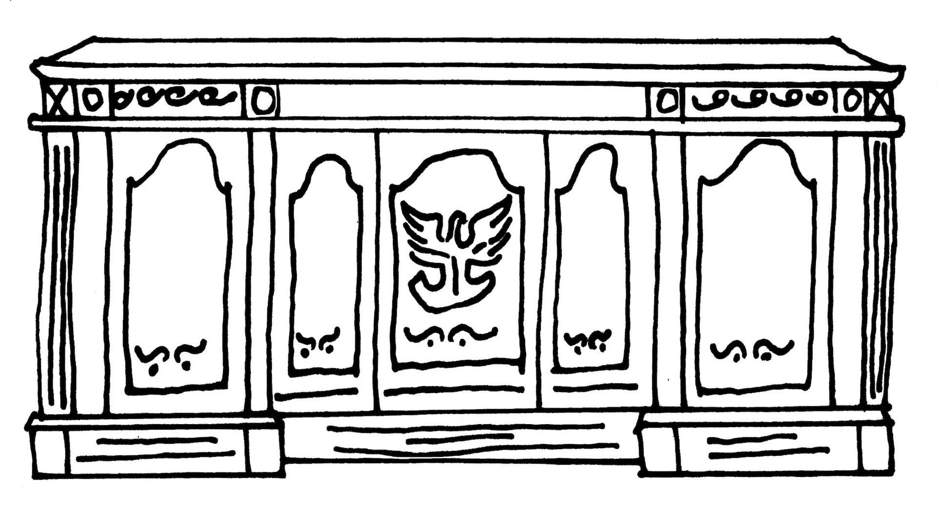

| **From the President’s Desk** |
| --- |

Hi friends,

Is a mess in your sewing space stealing your joy? Consider joining Karen Brown of [www.justgetitdonequilts.com/declutter-challenge-2025](http://www.justgetitdonequilts.com/declutter-challenge-2025) for her January declutter challenge. I did it once a few years ago and it was great. She chooses only one action each day, such as going through your patterns or your rulers, and I found it very helpful.

Which brings me to my next topic: favorite quilting websites. (Someone put this idea in the tip jar but I don’t know who…identify yourself?). Karen Brown mentioned above is my favorite for practical advice and free stash buster patterns on her YouTube channel—-not trying to sell anything. But let’s face it, as much as we like to support our local quilt shops, we do sometimes look online for quilt stuff. I think [www.keepsakequilting.com](http://www.keepsakequilting.com) is the original catalog and website where I found stuff, particularly wide backs. [www.fatquartershop.com](http://www.fatquartershop.com) is another huge retailer but also produces patterns and YouTube videos. For instructional videos and patterns, some free, I also like [jordanfabrics.com](http://jordanfabrics.com) although I also bought a nice fabric set once there too. I am in fact using one of her free patterns right now for a veteran’s quilt to donate in April.

The POLQ board will be meeting Jan. 6 to plan the second half of the year, so if you have any suggestions or concerns, please call me or one of the officers listed in your book. Otherwise, I’ll see you at our next meeting, 6pm at Ascend Jan. 9th.

Happy New Year! ~Ellen Lewellen

| **~ Dec. 12th Guild Meeting Minutes ~** |
| --- |

* **Call to Order**
  + Welcome
* **Program**
  + Christmas Party
    - Thank you to the creative minds behind the party! Emily B, Gretchen S, Julie K, Cindy D, Ellen L
* **Business Meeting**
  + Treasurer’s Report for November was shared verbally with the group.
  + **Quilt Show**:
    - **Raffle Tickets** for the Raffle Quilt are available, please see Ann Hall if you have not received your tickets, or need more! Members are expected to sell 30 tickets. (tickets are $1 each or 6 for $5). Bring sold ticket stubs and money to Ann Hall as you sell your tickets.
    - Julie P shared about a movie available on Amazon Prime. “The Fabric of Christmas.”
      * My (Naomi) extremely limited synopsis: He’s a firefighter; she’s a quilter. It’s Christmas time; there’s fabric; there’s probably romance. 👨🏼‍🚒🙋🏻‍♀️🎄🪡❤️ What more do you need?😉
    - Reminder: Painting Pathways is the chosen recipient of the funds raised in the Charity Booth and Raffle Basket Booth.
* **Show and Tell**
* **Christmas Program continued**
  + Show and tell was paused for the **Lake Effect Quartet**.
    - The quartet entertained with humor and harmony.
    - Favorites included “You’re a Mean One, Mr. Grinch,” and “You Ain’t Getting Diddly Squat (cuz you really messed up this year).”
* More quilts were shown, snacks shared, and fun was had for the rest of the evening.
* Submitted by Naomi Anderson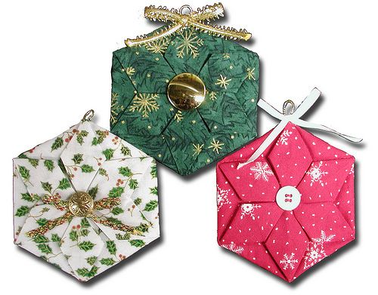

| **Fabric Hexagon Ornament** |
| --- |

[(viewing newsletter online? Click here for Video Tutorial)](https://www.youtube.com/watch?v=oq934F4_KKY)

Or, type in web address: **y**[**outube.com/watch?v=oq934F4_KKY**](http://youtube.com/watch?v=oq934F4_KKY)

Written directions were proving difficult without spending a lot of time adding visuals, so please utilize the above link, or ask a friend who was at the Christmas party.

| **⚘ ⚘ ⚘ 2025 Quilt Show Corner ⚘ ⚘ ⚘** |
| --- |

| **Quilt Show Set Up**: April 3 & 4  **Quilt Show Open**: April 5 & 6  Event at the MTWC Expo Center | **2025 Quilt Show Chairs:**  Julie Klumpp & Kathy Guralski |
| --- | --- |
| **Theme:** Garden Party | **Featured Quilter:** Mary Hutchison |

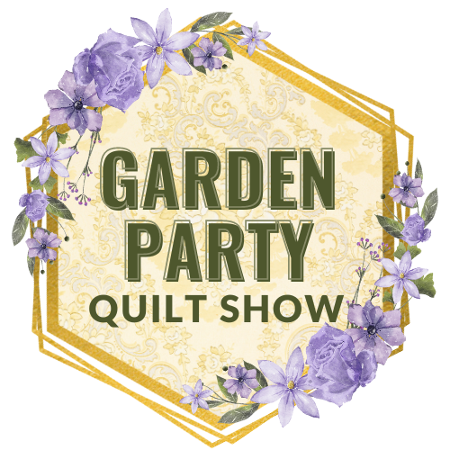

**Quilt Show General Info:**

[www.patchoflakeshore.com/qsmemberinfo](https://www.patchoflakeshore.com/qsmemberinfo)

If you have Quilt Show info you would like included (in the newsletter or website) send info to [naomianderson428@gmail.com](mailto:naomianderson428@gmail.com)

* **Work Schedule**
  + If you are a Committee Chair, please take time to contact Ellen Lewellen to let her know how many people you will need as helpers during the quilt show for each time slot (9am to 12noon & 12noon to 3pm for each day).
    - ie: Kid’s Corner needs 1 person per time slot
  + Members, keep in mind we will be asking you to fill two time slots during the quilt show.
* **Charity Booth and Raffle Baskets**
  + We would like to have homemade items for the *Charity Booth*. These items are sold in the Charity Booth with funds going to this year’s chosen charity: Painting Pathways. Consider donating a homemade item or two!
  + For the *Raffle Baskets:*
    - You can donate various quilting related items, especially fat quarters, that will be assembled and packaged by the committee.
    - Or, consider teaming up with some friends and making a whole basket yourselves. Does not have to be quilting themed: i.e. bird feeder and seed, BBQ items, game night theme (popcorn, snacks,card games).
* *Challenge Quilt:* Remember to work on your Challenge Quilt! (See website for specifications)

| **⚘ ⚘ ⚘ 2025 Quilt Show Corner Continued ⚘ ⚘ ⚘** |
| --- |

* **Gift Boutique**
  + For those members, especially our newest members, wanting to sell their wonderful creations in the Gift Boutique, any handmade items made by you are welcome. Here’s a chance to showcase your talents and earn a bit of money to support your fabric habit!
  + Any member is limited to display at any one time, a maximum of 12 items in any one of your categories. As sales are made, your supply may be replenished. Any extra items may be stored underneath the tables and should be placed in boxes or plastic bins with your name on it.
  + If you can display your items in a container, i.e., basket, bowl, decorative box – please do so, and put your name on the bottom of the container.
  + The Guild retains 10% of all sales.
  + An inventory list and sample price tag will be published in a future newsletter. We will also have them at upcoming meetings. We want you to use this uniform inventory list, as it will be much easier to keep an accurate record of all the sales.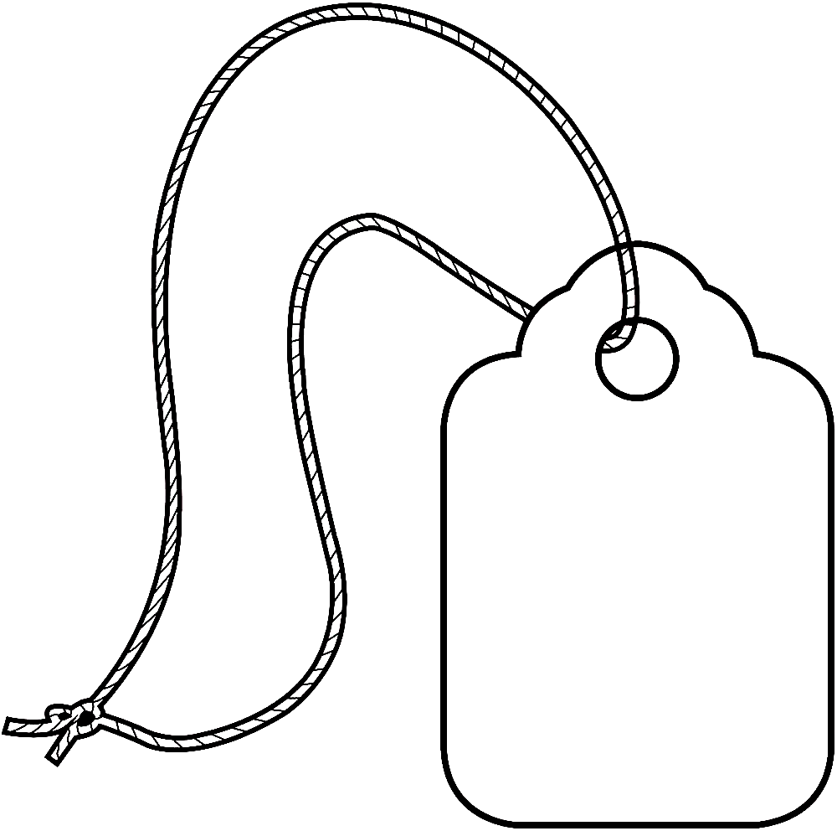
  + As to the price tags, Walmart has a box of 100 strung marking tags, by Avery, 1 3/4” x 1 3/32”, No. 6732.
  + Please number your items consecutively.
  + Each and every item must have a price tag attached to it with a safety pin. Please set your pricing at full dollar or half-dollar amounts for ease in making change.
  + Anyone still wishing to donate gently used gift bags can bring them to our meetings. We will donate the tissue paper.
  + We would like to have three people on each shift. Two at the checkout and one to help the customers by walking around and keeping an eye out for anyone wanting an item and “forgetting” to pay for it.
  + You, or the person dropping off your items, will be asked to sign a disclaimer. The drop-off dates and times will be announced later.
  + If you have any questions, please contact  
    Mary Kay Burish [mkburish@baytitle.com](mailto:mkburish@baytitle.com) 682-7006   
    or Bonnie Loeh [bnloeh@gmail.com](mailto:bnloeh@gmail.com) 682-3259

| **☆ ☆ ☆ Quilts for Veterans ☆ ☆ ☆** |
| --- |

After the great success of the **Quilts for Veterans** during the 2023 Quilt Show, it was decided to continue this quilt show also. Quilts can be made with a specific vet in mind, or can be made as a donation and will be given to an area vet.

*Making a quilt to donate to a veteran? Please keep the following in mind.*

* A Lap Quilt is a preferred size for many.
* Keep your colors patriotic and purposeful.   
   True red, white and blue. Deep, saturated colors, not pastels.
* Same goes for the prints themselves. No floral, seasonal or religious.
* Please put a label on your quilt

Your quilt will be truly treasured by a Veteran.

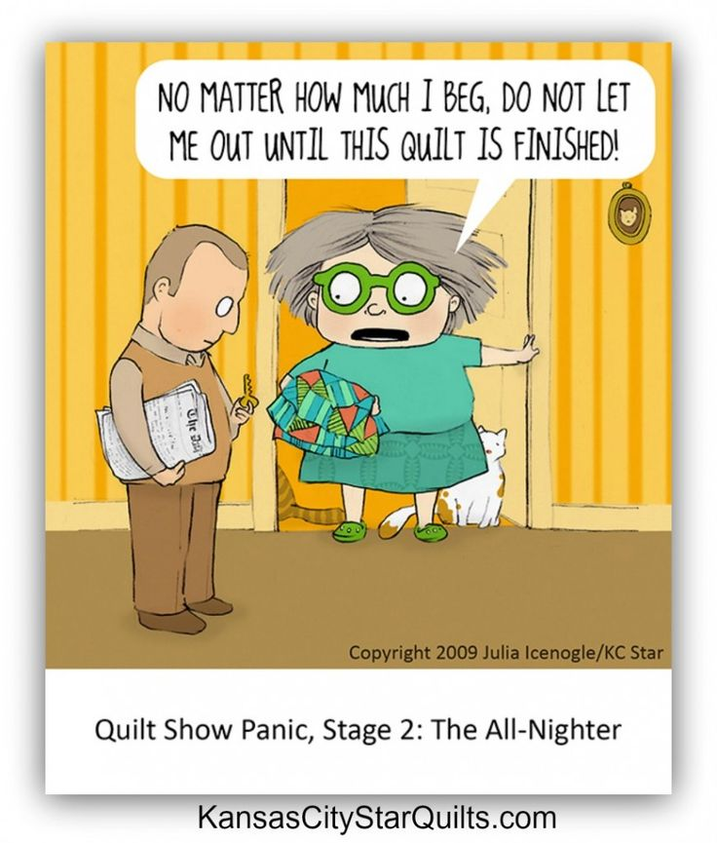

| **Some General Guild Info** |
| --- |

**~Charity Committee:** There are no planned sewing days specifically for charity quilts. Feel free to continue making quilts/items for donations to area programs as you so desire. Contact Winne K with any questions.

* + InCourage: Pillowcases
  + The Crossing: Baby Blankets
  + Humane Society: dog and cat bed/quilts

**~Charity Labels** now available at Guild Meetings. See Naomi A

**~Website**: We need some help to edit and update our Guild History. i.e. streamline the info, update with some current charities we are supporting, etc. Naomi will do the loading of the info to the website

| **? ? ? 2024-2025 Mystery Quilt ? ? ?** |
| --- |

~ Pattern on page 6 ~ quantity: make 1 block ~

If you love making half square triangles this is the block for you, there are 12 of them. Have fun using a lot of colors. ~Chris B

