**NEWSLETTER**

Volume 20 Issue 07 August 2024

| **Next Regular  Guild Meeting:**  September 12, 6pm  ~At Ascend Services  ~2818 Meadow Lane, MTWC | **Upcoming Guild Events:**  ~August 8, 6pm  **Guild Member Picnic**  see below  ~Sept 13-15  **Fall Camp Quilt**  See page 6 |
| --- | --- |
| **Quilt Show Corner - Page 4-5** | |

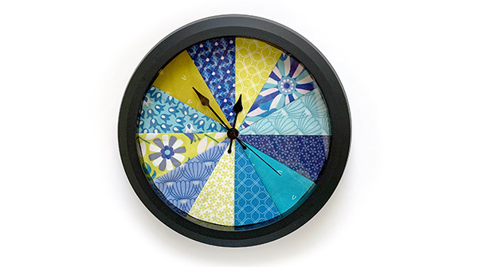

**Starting September:  
NEW 6pm GUILD TIME!**

| **August 8 Guild Picnic** |
| --- |

*IMPORTANT CORRECTION*: **The Picnic starts at 6pm**



*Come to our Tropical themed Guild Picnic.*

August 8 at Ascend Services

* Wear your favorite tropical outfit (👙no bikinis please😄), sunglasses, sun hat, whatever you can think of.
* Bring a 10.5 inch white and bright Pineapple Quilt Block ([when on a computer, click here to be taken to the pattern website!](https://www.sewwhatyvette.com/pineapple-quilt-block-made-easy/)  
  Or [click here for the same pattern in a pdf file](https://www.sewwhatyvette.com/wp-content/uploads/2020/05/Pineapple-block-any-ruler.pdf)) (if you receive the newsletter via snail mail, I {Naomi} will include a printed pdf file)
* No pineapple block? That’s ok, come anyway!

| **~ Patch of Lakeshore Quilters ~ June 13, 2024 Guild Meeting Minutes ~** |
| --- |

* **Call to Order & Pledge** - Ellen Lewellen
* **Program**
  + Caroline Knox of CDK STUDIOS ([cdkstudios.com](http://cdkstudios.com))
  + T-Shirt Quilt: Making Memories Last
    - Basic Tips
      * Clean the T-Shirts!
      * ALWAYS use a stabilizer (sheerweight iron-on)
      * Prewash your quilt back fabric
* **Snacks, social, and Show & Tell**
* **Business Meeting**
  + **Old Business**
    - Motion to accept Secretary & Treasurer Report:
      * Gretchen Scheidt 2nd: Chris Bauknecht Accepted
    - Quilt Show
      * Changes to Quilt Show Registration Form
        + Additional breakdown of largest category, based on size and who did the quilting

(registration form will be updated on website and will include info about the various categories)

* + - * Suggestions being taken for a local charity organization to receive funds generated from the Charity Booth and Raffle Basket areas of the 2025 Quilt Show
    - Bucket Hat Class by Mary Ellen Beebe
      * July 20th, 9am-3pm at Ascend, $10
    - Sew for Fun
      * June 22 & 23,
      * $10 per day, to help offset cost of building use
      * Contact Julie Klimpp to sign up
    - Membership Form
      * We use this to create the membership directory, so make sure your info is correct and up to date.
    - Fair Quilt
      * Ann ZeMan, Ellen Buck & Jeanette Wiesner
        + Take the challenge and make a quilt block for the Manitowoc County Fair
        + Click on link for quilt block info: link: [Quilt Block info](https://manitowoccountywi.gov/wp-content/uploads/2024/05/Quilt-Block-Contest-Rules-and-Regulations-2024.pdf)
        + Looking for volunteers to sell raffle tickets during the County Fair

| **June 13, 2024 Guild Meeting Minutes Continued** |
| --- |

* + **New Business**
    - August Picnic
      * Held at Ascend, details coming
      * Contacts include: Linda Londo, Pam Posvic, …
    - Mary Ellen Beebe
      * Gauging interest for fat quarter quilts group
    - Challenge Quilt for the 2025 Quilt Show info is released!
      * Quick summary (full details in main portion of newsletter)
        + Overall Measurements: up to 100” Maximum inches total, any size (ie 25x25x25x25 OR 30x10x30x10)
        + Can be an Original work or a pattern (no kits)
        + Must follow theme of show: Garden Party
    - Election of officers
      * Approved Election Ballet
        + Lori Hansen-Stein for Vice President

2nd Tina Waack Approved

* + - * + Mary Ellen Beebe for Treasurer

2nd Jennifer Posvic Approved

* + - * + Ann Hall, Sue Mardquardt, Rosalie Miller for Member at Large (voting for One open position)

2nd Marlene Denor Approved

* + - * Voting Results
        + Vice President: Lori Hansen-Stein
        + Treasurer: Mary Ellen Beebe
        + Member at Large: Ann Hall
* **Motion to adjourn**
  + Tina Waack 2nd: Marlene Denor accepted

| **Charity Donations** |
| --- |

We will be showcasing our charitable donations at the 2025 Quilt Show. Nan Groll or Kay Olker are looking for fliers from the places that receive our quilts.

Also, if you donate quilts to various charities, snap a picture and get it (email or text or physical copy) to Nan Groll and/or Naomi Anderson. This helps us for record keeping and for the show.

Labels with the guild’s name will be available to take and use starting at the September guild meeting.

| **Shared with the guild:** |
| --- |

*"****Forty and Fabulous" Sheboygan County Quilters Guild Quilt Show***

*Saturday, September 14th, 2024, 9:00 to 4:00 p.m.*

*Sheboygan County Christian School Campus, 929 Greenfield Avenue, Sheboygan, WI 53081*

* *Quilts and quilted items displayed for viewer's enjoyment*
* *Vendors and members selling a wide array of quilting related items from thread to sewing machines*
* *Raffle with prizes of quilts, quilted items made by guild members*
* *Lunch and Refreshments available on site*

*Admission of $5.00. Children 12 years and under FREE*

| **⚘ ⚘ ⚘ 2025 Quilt Show Corner ⚘ ⚘ ⚘** |
| --- |

| **Quilt Show Set Up**: April 3 & 4.  **Quilt Show Open**: April 5 & 6  Event at the MTWC Expo Center | **2025 Quilt Show Chairs:**  Julie Klumpp & Kathy Guralski |
| --- | --- |
| **Theme:** Garden Party | **Featured Quilter:** Mary Hutchison |

New info:

* Fat Quarter donations are being accepted for the raffle baskets at the quilt show. Linda Londo is a contact person for the raffle baskets.
  + Funds received from the raffle baskets go towards a local charity (still being determined).
* **Challenge Quilt**
  + Submitted piece must be in quilt form: 3 layer sandwich: fabric top, batting and fabric back, quilted.
  + Overall measurements not to exceed 100” total on all sides (ie 25x25x25x25 OR 10x40x10x40). Can be any shape.
  + May be an original work or a pattern. No kits.
  + Must follow theme of the show: Garden Party.
  + Must use a recognizable amount of any floral fabric in piece. Other fabrics may be used as well.
  + Piece must be registered on standard form (coming out sometime this fall) that is distributed by guild and submitted per deadline/instructions on form.

| **⚘ ⚘ ⚘ 2025 Quilt Show Corner - Continued⚘ ⚘ ⚘** |
| --- |

* **In Search Of:**
  + Hello everyone, Naomi here. I’m wearing my “Props Committee Chair Hat” to ask you for some supply donations.
  + Just so we’re all on the same page, these items will NOT be returned to you (so “sharing” grandma’s special florals, or your seasonal florals that you still want to use is not a good idea).
    - Think thrift shops, garage sales, or items you are cleaning out of your home.
  + Items I’m looking for:
    - Florals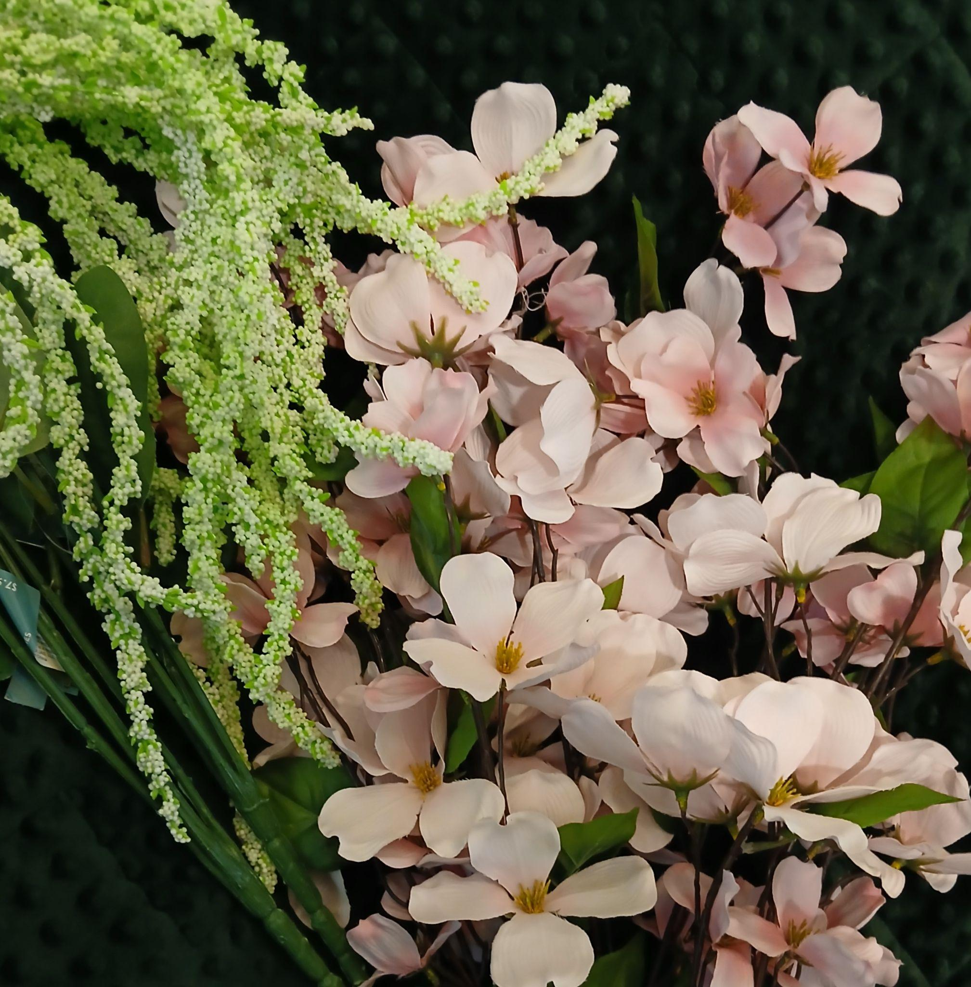
      * Greenery (think ivys, and leafy greens)
      * Florals in white, pinks and purples, especially “droopy” flowers (think wisteria-like)
    - Embroidery Hoops
      * Any size, any type, any color
    - Doilies and Lace type items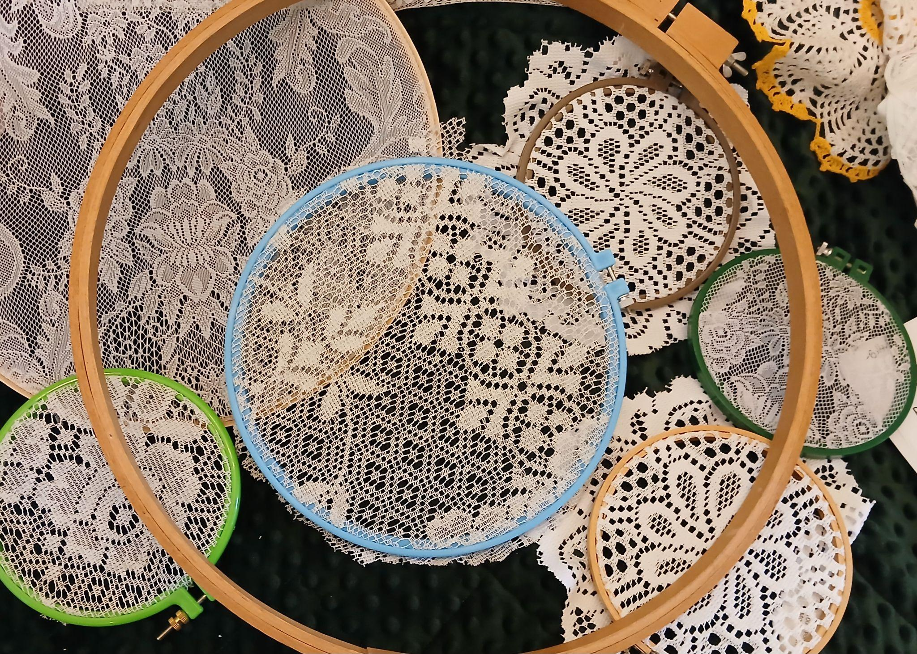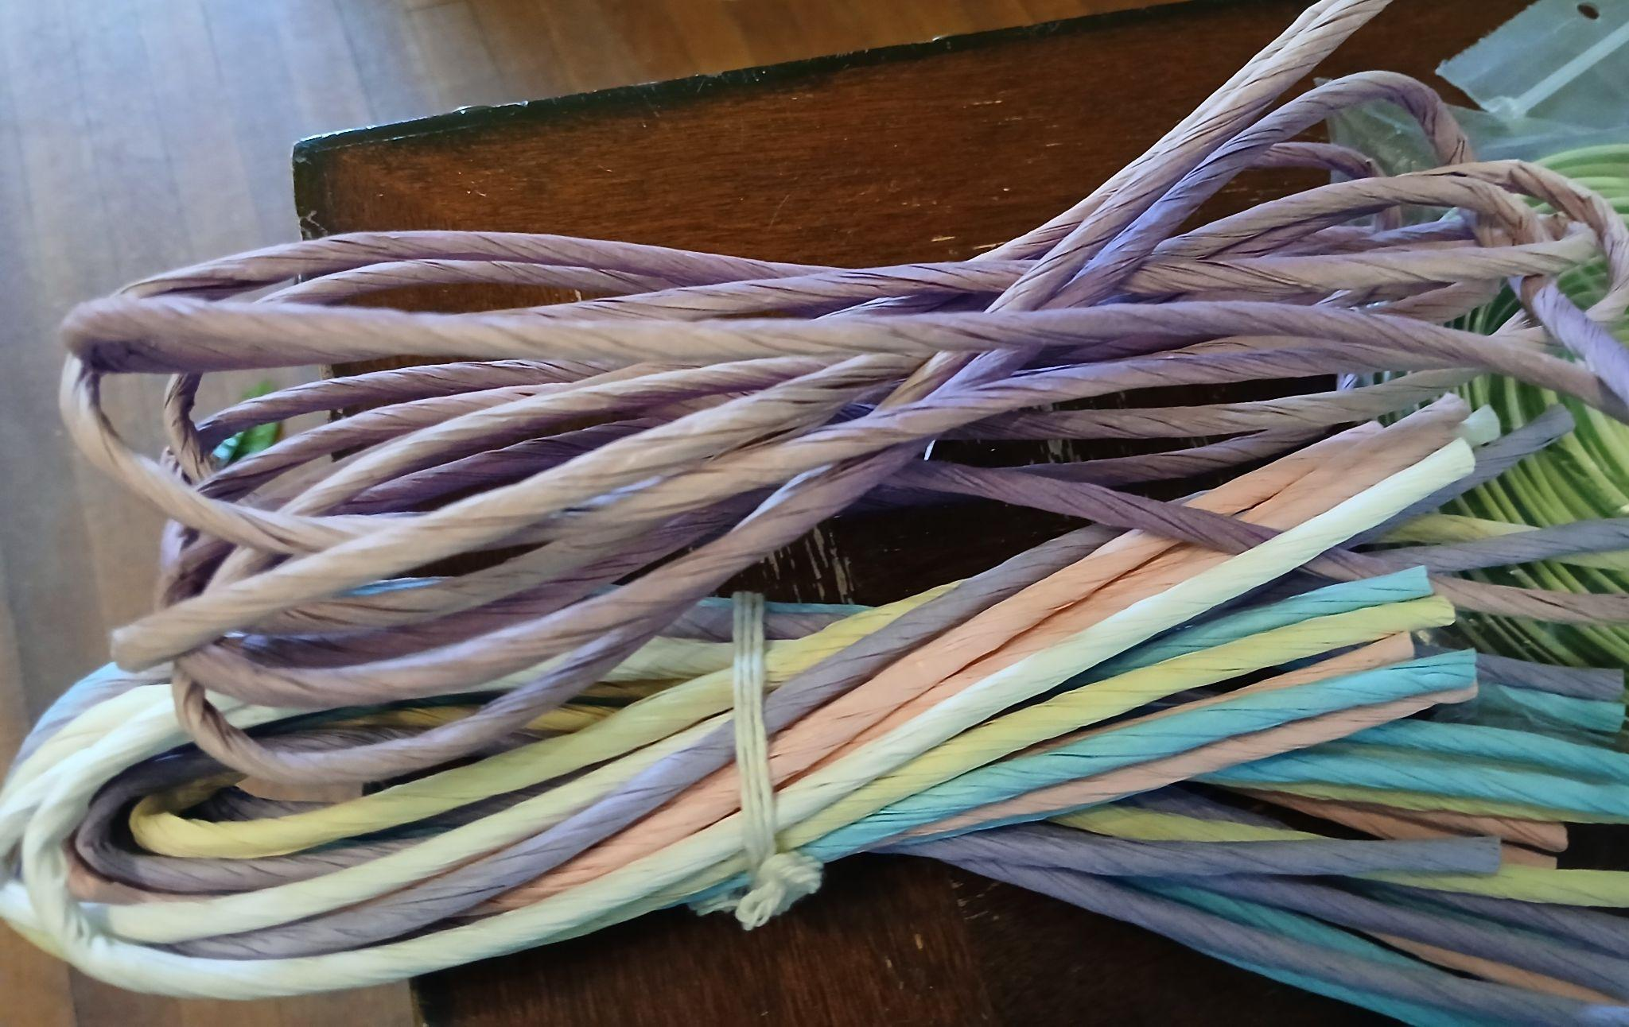
      * Old curtains, table runners, etc
      * Fyi, these will likely be cut up, so nothing valuable
    - Twisted crafting paper
      * You remember, the stuff everyone used to make christmas angel ornaments out of. 😄
      * White, ivory, pinks, purples, and greens

**Quilt Show General Info:**

While the newsletter will have information about the quilt show, the best way to access all the needed info will be the [Guild Website](http://www.patchoflakeshore.com). I (Naomi) continue to work on building a webpage about the Quilt Show in general (specifically for public knowledge), and a page especially for guild members. This page will have information about committees, registration forms for quilts being entered into the show, and more.

If you have Quilt Show info you would like included (in the newsletter or website), send me an email at [naomianderson428@gmail.com](mailto:naomianderson428@gmail.com).

| **Fall Camp Quilt - Sept 13-15** |
| --- |

Quilt Camp is an opportunity to sew with guild friends and enjoy time away!

Bring your own sewing machine, basic supplies and projects. The Guild provides irons, ironing boards, cutting mats…plus lots of friendly tips and delicious food.

**Dates**: Sept. 13-15, 2024

**Location:** Camp Tapawingo, 915 Tapawingo Rd, Mishicot, WI

There will be no overnight stay. Open House style from 8am to 11pm.

**Cost**: $55 for members, $75 for non-members

**Meals**: Guild provides: *Fri*: supper; *Sat*: brunch and supper; *Sun*: brunch

*optional*: Friday 8am breakfast at Two Rivers Family Restaurant, pay for self

**Door prizes**: Anyone at camp who wishes to participate in “BOGO” drawing brings a wrapped ($10.00) gift.

**Project**: We will present a project on Saturday. Participation is voluntary.

*For the project, bring:*

* Two coordinating fat quarters
* One plain fat quarter (this one is nots see, so could be ugly fat quarter 😄)

**Questions**: Julie Klumpp 920-860-0485 or jaklumpp@tm.net

**QUILT CAMP REGISTRATION**

**September 13-15, 2024**

NAME: ____________________________________________________

ADDRESS: __________________________________________________

PHONE: ___________________________________________________

MEALS: CHECK WHICH YOU WILL BE PRESENT FOR

______ ALL MEALS

______ FRIDAY SUPPER

______ SATURDAY BRUNCH ______ SATURDAY SUPPER

______ SUNDAY BRUNCH

ARE YOU A COFFEE DRINKER? ______YES ______NO

IF YES, HOW MANY CUPS A DAY _____, REGULAR _____, DECAF _____

CAMP PAYMENT: MAKE CHECKS PAYABLE TO PLQ-QUILT CAMP

$55 MEMBERS $75 NON-MEMBERS

MAIL TO: JULIE KLUMPP, 2123 PRIMROSE LANE, MANITOWOC, WI 54220

QUESTIONS: JULIE KLUMPP, 920-860-0485 OR JAKLUMPP@TM.NET