**NEWSLETTER**

Volume 20 Issue 11 December 2024

| **Next Regular  Guild Meeting:**  Dec 12, **6pm**  ~At Ascend Services  2818 Meadow Lane, MTWC | **Upcoming Guild Events:**  **Quilt Show Committee Meeting**  Dec 9, 6pm at  The Quilt Shop of Two Rivers |
| --- | --- |
| **Quilt Show Corner - Page 5-6**  **Mystery Quilt - Page 7** | |
| **December is the Guild’s Holiday Party! See page 2 for details.** | |

**Remember:**NEW GUILD TIME:

6PM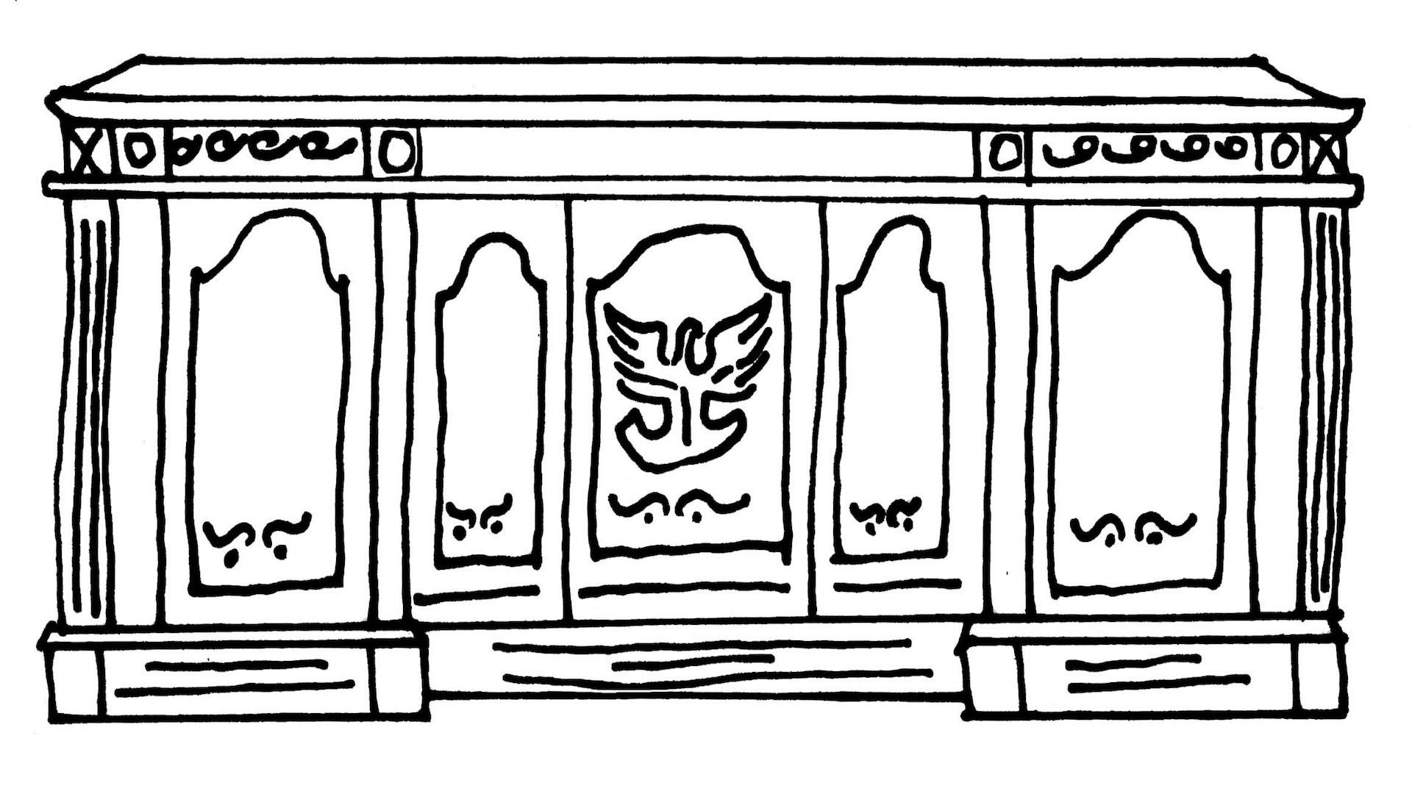

| **From the President’s Desk** |
| --- |

The day after our November meeting, 11 of our guild members and guests carpooled to Cedarburg to the Wisconsin Museum of Quilts and Fiber Arts. Our docent was informative and I think we all came away with a renewed appreciation for our foremothers and the history of quilting. 🪡 It was also an inspiration to get quilting ourselves and to label our projects for possible future generations. We had a tasty lunch together in Cedarburg then split up to visit quilt shops…pretty much a perfect day😁

Elsewhere in this edition please find the invitation to our guild holiday party for the December meeting. The committee, Gretchen Scheidt, Cindy Dillman, Emily Bosovich, Julie Puestow and I have planned a fun evening you won’t want to miss! Of course you are welcome to wear your favorite festive outfit, but we really want to see what you come up with to wear as a hat or headgear 🎩👒👑 …zaniness encouraged and there will be a prize! Also, don’t forget you are asked to bring a wrapped”white elephant” gift🎁. This doesn’t have to be useful or quilt-related and can be anything at all that you think we’d have fun watching someone unwrap.😜

See you at the party!🎊. Ellen Lewellen

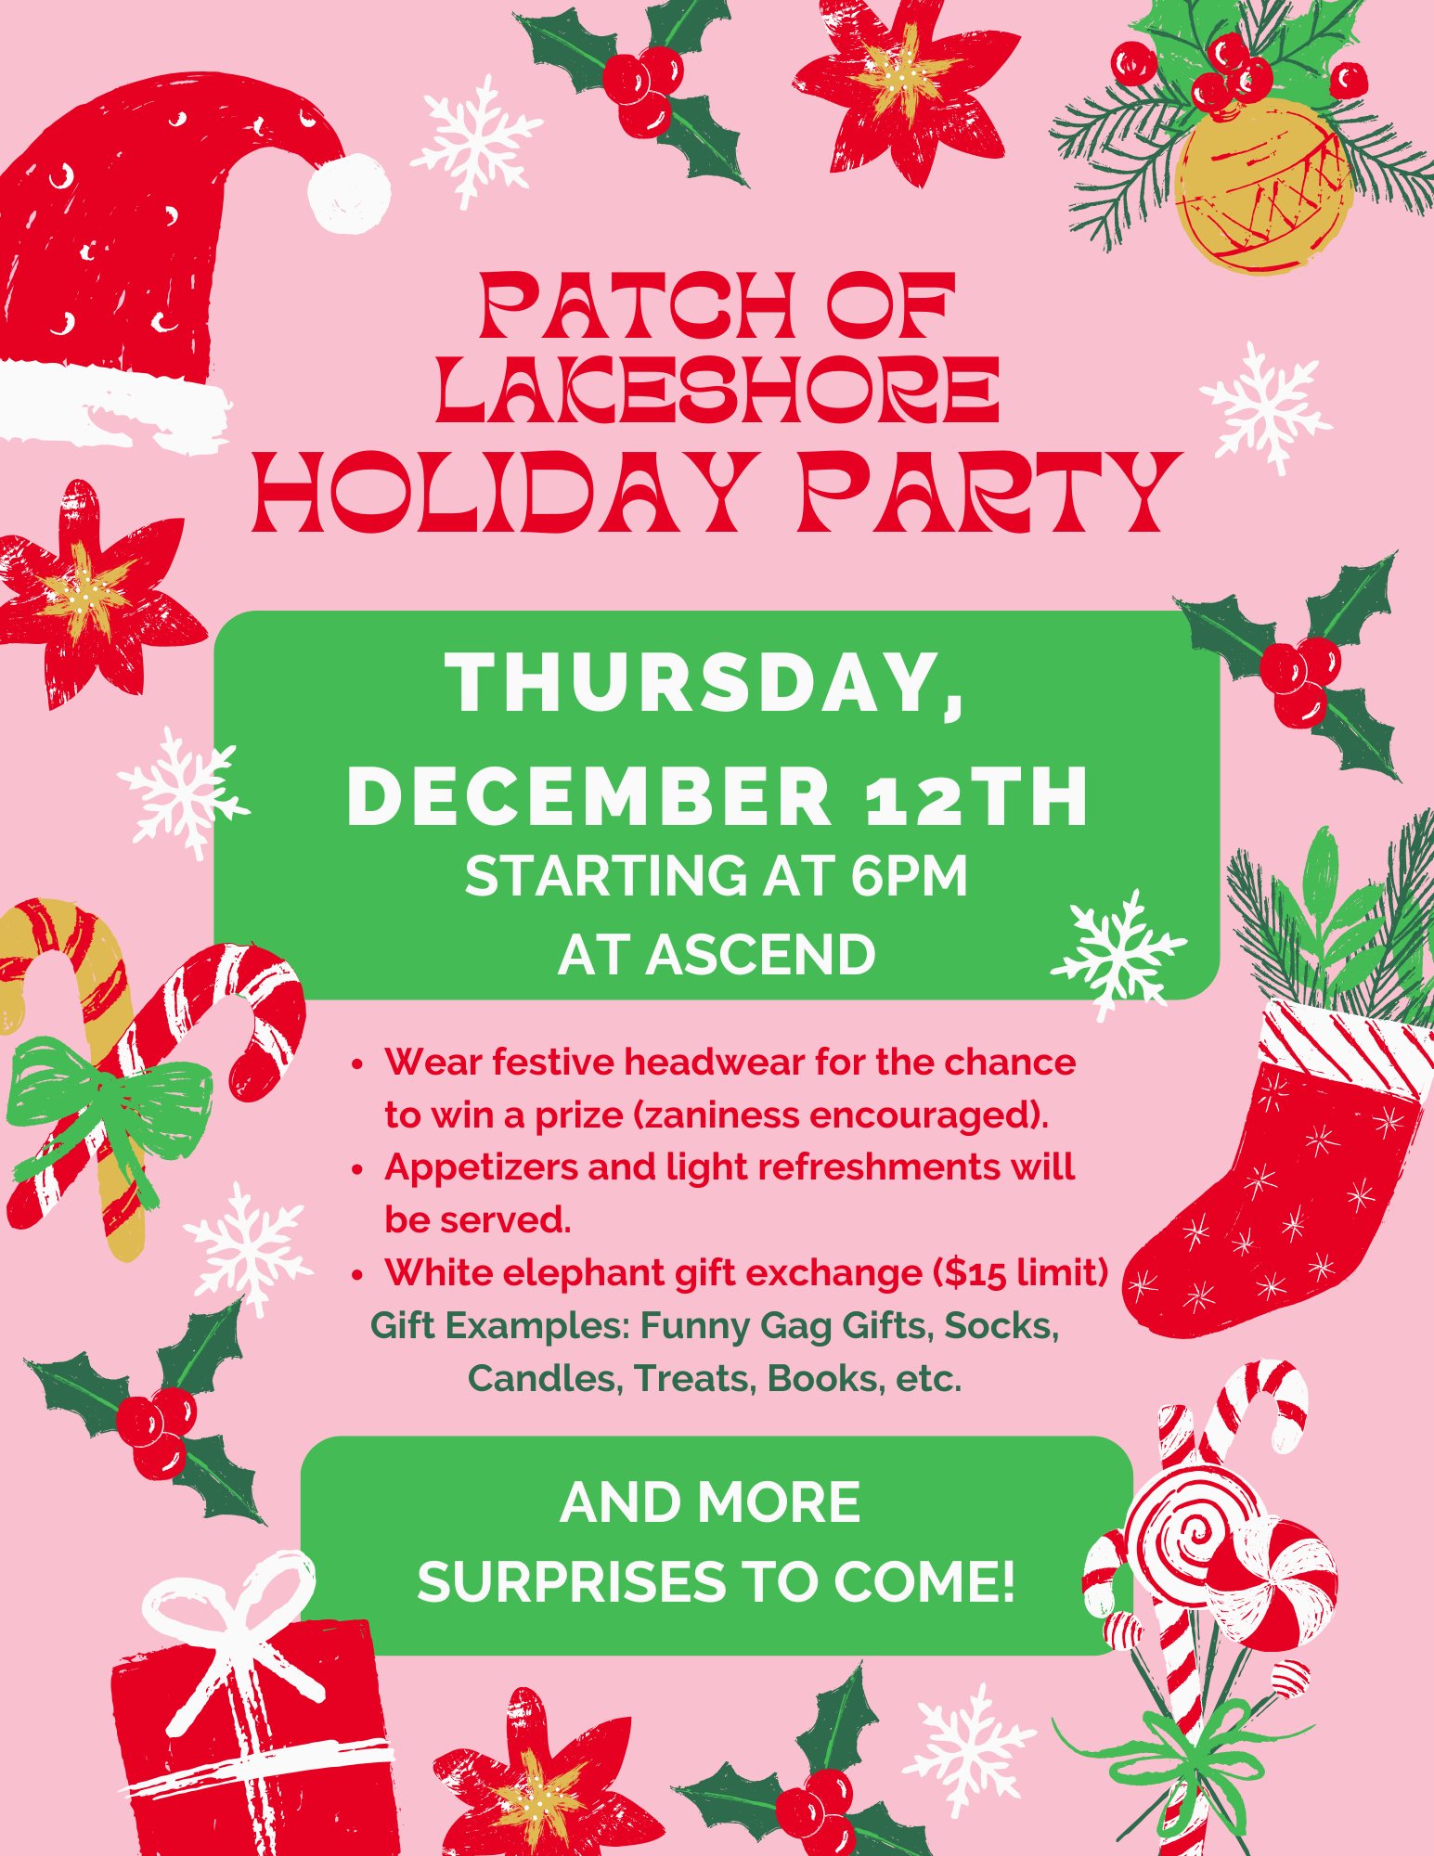

| **~ Nov. 14 Guild Meeting Minutes ~** |
| --- |

* **Call to Order**
  + Welcome
  + Pledge
* **Program**
  + Guild Member Mary Ellen Beebe
    - The guild was treated to a beautiful trunk show highlighting Mary Ellen’s progress in quilting through the years. Quilts included Halloween to Modern, One Block Wonders to beading, and many others.
* **Social Time**
* **Show and Tell**
* **Old Business**
  + Treasurer’s Report and Secretary’s Report.
    - Motion to accept: Lori Hansen-Stein 2nd: Rosalie Miller Carried
  + **Quilt Show**: From Nov. 11 Committee Chair Meeting
    - From the *Charity Committee* (in charge of the Charity Booth [which sells made items donated by the guild] and Raffle Baskets [which collect themed items to create baskets to raffle off during the Quitlt Show]): It was mentioned at past shows that some people like pillowcases in matching pairs. Consider making sets of pillowcases.
    - *Food Committee:* Newton Meats donating hot dogs.
    - *Props Committee:* Still in need of embroidery hoops (any size, any color) and greenery. Contact Naomi Anderson
    - Considering a “Make and Take” for at the Quilt Show.
    - *Challenge Quilt:* Remember to work on your Challenge Quilt! (See website for specifications)
    - *Registration Form updates:*
      * Judged Quilts: fee raised to $7
      * Traditional Pieced category
        + Broken down into smaller sub-categories. Read the description on the second page of the Registration Form carefully to help assign your quilts appropriately.
      * Novice Category: definition updated to mean someone with 1 to 2 years quilting experience.
    - Tickets for the Raffle Quilt are now available! See Ann Hall for more.
    - Reminder: Painting Pathways is the chosen recipient of the funds raised in the Charity Booth and Raffle Basket Booth.
* **New Business**
  + **Mystery Quilt** Chris B fell and broke a vertebrae, so block releases may be delayed

| **~ Nov 11 Guild Meeting Minutes Continued ~** |
| --- |

* + **Charity Committee:** There are no planned sewing days specifically for charity quilts. Feel free to continue making quilts/items for donations to area programs as you so desire. Contact Winne K with any questions.
    - InCourage: Pillowcases
    - The Crossing: Baby Blankets
    - Humane Society: dog and cat bed/quilts
  + **Charity Labels** now available. Naomi A will have them available at Guild Meetings.
  + **Website**: We need some updating of the History information. Naomi will do the loading of the info to the website; we just need someone who will take the time to update the info. i.e. streamline the history info, update with some current charities we are supporting, etc.
  + **Field trip**: Wisconsin Museum of Quilts and Fiber Arts, Nov. 15
  + **Sew Day** Nov. 16 & 17, 8am - 4pm
  + Craft show at Meadow Lanes North, Nov. 15 & 16.
  + Pearl S also had a fall and is recovering.
* **Show and Tell**
  + Lots of lovely quilts shared! Wonderful job everyone! Special shout out to our newer members sharing their work with us all!
* **From the Tip Jar**: Marlene Denor shares: When hanging wall quilts, use a sewing machine needle! Makes a smaller hole in the wall and is very strong!
* Motion to adjourn
  + Pam Posvic second Gretchen Scheidt motion carried
* Submitted by Naomi Anderson

| **☆ ☆ ☆ Quilts for Veterans ☆ ☆ ☆** |
| --- |

**Guidelines for Quilts for Veterans.**

Making a quilt to donate to a veteran? Please keep the following in mind.

* A Lap Quilt is a preferred size for many.
* Keep your colors patriotic and purposeful.   
  True red, white and blue. Deep colors, not pastels.
* Same goes for the prints themselves. No floral, seasonal or religious.
* Please put a label on your quilt

Your quilt will be truly treasured by a Veteran.

| **⚘ ⚘ ⚘ 2025 Quilt Show Corner ⚘ ⚘ ⚘** |
| --- |

| **Quilt Show Set Up**: April 3 & 4  **Quilt Show Open**: April 5 & 6  Event at the MTWC Expo Center | **2025 Quilt Show Chairs:**  Julie Klumpp & Kathy Guralski |
| --- | --- |
| **Theme:** Garden Party | **Featured Quilter:** Mary Hutchison |

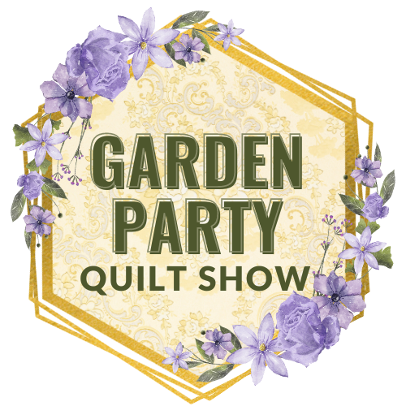

**Quilt Show General Info:**

Keep up to date by visiting the [Guild Website](http://www.patchoflakeshore.com).

A webpage containing information for members about the quilt show is up. [www.patchoflakeshore.com/qsmemberinfo](https://www.patchoflakeshore.com/qsmemberinfo)

If you have Quilt Show info you would like included (in the newsletter or website), send me an email at [naomianderson428@gmail.com](mailto:naomianderson428@gmail.com).

* **Charity Booth and Raffle Baskets**
  + We would like to have homemade items for the *Charity Booth*. These items are sold in the Charity Booth with funds going to this year’s chosen charity: Painting Pathways. Consider donating a homemade item or two!
  + For the *Raffle Baskets:*
    - You can donate various quilting related items, especially fat quarters, that will be assembled and packaged by the committee.
    - Or, consider teaming up with some friends and making a whole basket yourselves. It does not have to be quilting themed. i.e. bird feeder and seed, barbequing items, game night theme (popcorn, snacks and a few card games).
* **Props Committee**
  + If you offered to help me, please be so kind and remind me (Naomi Anderson)! 😆 I didn’t write anyone's names down. I need just a few helpers for the January meeting, during which we will be making some of the props.
  + Also, Thanks for the donations so far!
    - Still accepting embroidery hoops and florals, specifically greenery, and white, pink, purple flowers, especially droopy styles.

| **⚘ ⚘ ⚘ 2025 Quilt Show Corner Continued ⚘ ⚘ ⚘** |
| --- |

* **Gift Boutique**
  + For those members, especially our newest members, wanting to sell their wonderful creations in the Gift Boutique, any handmade items made by you are welcome. Here’s a chance to showcase your talents and earn a bit of money to support your fabric habit!
  + Any member is limited to display at any one time, a maximum of 12 items in any one of your categories. As sales are made, your supply may be replenished. Any extra items may be stored underneath the tables and should be placed in boxes or plastic bins with your name on it.
  + If you can display your items in a container, i.e., basket, bowl, decorative box – please do so, and put your name on the bottom of the container.
  + The Guild retains 10% of all sales.
  + An inventory list and sample price tag will be published in a future newsletter. We will also have them at upcoming meetings. We want you to use this uniform inventory list, as it will be much easier to keep an accurate record of all the sales.
  + As to the price tags, Walmart has a box of 100 strung marking tags, by Avery, 1 3/4” x 1 3/32”, No. 6732.
  + Please number your items consecutively.
  + Each and every item must have a price tag attached to it with a safety pin. Please set your pricing at full dollar or half-dollar amounts for ease in making change.
  + Anyone still wishing to donate gently used gift bags can bring them to our meetings. We will donate the tissue paper.
  + We would like to have three people on each shift. Two at the checkout and one to help the customers by walking around and keeping an eye out for anyone wanting an item and “forgetting” to pay for it.
  + You, or the person dropping off your items, will be asked to sign a disclaimer. The drop-off dates and times will be announced later.
  + If you have any questions, please contact  
    Mary Kay Burish [mkburish@baytitle.com](mailto:mkburish@baytitle.com) 682-7006   
    or Bonnie Loeh [bnloeh@gmail.com](mailto:bnloeh@gmail.com) 682-3259

| **? ? ? 2024-2025 Mystery Quilt ? ? ?** |
| --- |

~ Pattern on page 7 ~ quantity: make 1 block ~

Remember to bring your completed blocks to the guild for show and tell!

~Chris Bauknecht

