**NEWSLETTER**

Volume 20 Issue 10 November 2024

| **Next Regular  Guild Meeting:**  Nov 14, **6pm**  ~At Ascend Services  2818 Meadow Lane, MTWC | **Upcoming Guild Events:**  **Quilt Show Committee Meeting**  Nov. 11, 6pm at  The Quilt Shop of Two Rivers  **Cedarburg Fieldtrip**  Nov. 15 Details on page 4  **Open Sew Day:**  Nov. 16 & 17 at Ascend |
| --- | --- |
| **Quilt Show Corner - Page 4-5**  **Mystery Quilt - Page 5-6** | |
| **Nov. hostesses:** Jenny Martin, Lori Hansen-Stein, Mary Ellen Beebe, Mitzi Pilon | |

**Remember:**NEW GUILD TIME:

6PM

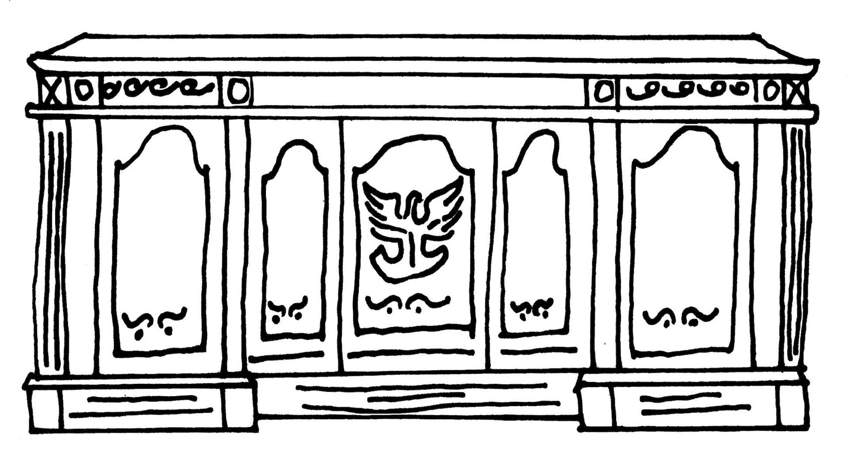

| **From the President’s Desk** |
| --- |

As November gets underway our thoughts turn to…quilting! Our regular monthly POLQ meeting will be on Nov. 14 at the new 6 PM start time. The next day, Friday Nov. 15th, there is an opportunity for a fun field trip to Cedarburg to visit a docent-led quilt exhibit at the Wisconsin Museum of Quilts and Fiber Arts, lunch at a cool place, followed by optional stops at one or more quilt shops. Then, with new inspiration and the fabric you bought, you can come to sew days on Sat. 11/16 and/or Sunday 11/17 at Ascend. All of these opportunities are not to be

missed because you’ll also be spending time with your POLQ friends! Call me if you have questions. Hope to see you soon! Ellen Lewellen

| **~ Open Sew Day - Nov. 16 & 17 ~** |
| --- |

Open Sew Day at Ascend

8am to 4pm both days

BYO machines and projects. Extension cords, ironing boards and irons provided

Cost is $10 a day, which helps cover the rental cost.

BYO lunch

Sign up at Nov. Meeting or contact Julie Klumpp

**Optional Sew Day project:**

If you have a Featherweight machine collecting dust or are a dedicated user of your Featherweight, you can create some accessories for it.

On Sat November 16 and Sunday Nov 17 we have an open sew day at Ascend and I would like to introduce you to two items you can make to go with your Featherweight machine. You should be able to complete both projects Saturday morning. First, is a cover to place over the bed of your machine to protect the bed from scratches on the thumb screw on the front of the machine. Second, is a bag just the right size to hold your cord and presser foot. This also protects your machine from scratches while transporting it. If this is something you are interested in please let me know so that I can have enough directions printed and I will then send you the supply list.

Contact me at frankandchris@lakefield.net or phone 920-901-2289.

Thank you, Chris Bauknecht

| **~ Oct. 10 Guild Meeting Minutes ~** |
| --- |

* **Call to Order**
  + Welcome guests and new members
  + Pledge
* **Program**
  + Sgt. Paul Kruck
    - Sgt. Kruck shared about the risk of scams.
    - A few tips:
      * Scammers use urgency and pressure to try and gain your information. Also secrecy; “don’t talk to anyone about it.”
      * Grandparent scam: caller acts like they are one of your grandchildren and that they need help in the way of money.

| **~ Oct. 10 Guild Meeting Minutes Continued ~** |
| --- |

* + - A few other scams to be aware of: Technical Support scams, Email Scams, Social Security Scams, Medicare Scams, Romance Scams, Facebook Scams, Lottery & Sweepstakes Scams and Law Enforcement Scams
    - Keep in mind:
      * Don’t send money to someone you don’t know
      * Legitimate businesses don’t request payment by giftcards
      * Block unwanted phone numbers
      * Resist pressure to act immediately
      * Stop and talk to someone you trust
    - Scams can be reported to police department/fed trade commission
* **Social Time**
* **Show and Tell**
* **Old Business**
  + **Mystery Quilt** (16 blocks plus sashing) - Block shown by Chris Bauknecht
  + **Sew Day** Nov. 16 & 17, 8am - 4pm
  + Name Tags - previous source no longer making name badges. Crawley Corp suggested for new vendor.
* **New Business**
  + **Quilt Show**
    - Guidelines for vets quilts
    - Voted on recipients of charity monies. Winner: Painting Pathways
    - Short synopsis of Quilt Committee meeting was given
  + Email from Barb - thank you for making fair a success
    - 2025 Fair theme: Let’s Rock and Roll at the Fair.   
      Colors: Black, Pink, Blue
  + Discussed committees in membership booklet
  + History page on the website needs editing and review of this page. Looking for a volunteer to help with this.
  + Trip for guild. The Quilt Museum in Cedarburg has a tour of history.
  + Basket ideas (for quilt show raffle) Fat Quarters, jelly rolls. Last show had 20 baskets, 10 for each day.
  + Good comment shared for 6pm start time.
* Motion to adjourn
  + Sue Marquardt second Julie Klumpp motion accepted
* Submitted by Julie Klumpp

**Quilting Road Trip!!! November 15 to Cedarburg!!!**

Call your girlfriend (non-member guests are welcome) and make plans to join us

for a fun outing to Cedarburg on Friday, Nov, 15th.

We will:

• **Visit the Wisconsin Museum of Quilts and Fiber Arts** for a docent-led tour of their special exhibit of “Pattern, Rhythm and Play”. They have given us a discounted price of $7 for seniors/$10 everyone else.

• \***Go to lunch together**. Depending on the group size, I hope to take you to “Cream and Crepe” which is a long time favorite housed in an old mill which

specializes in savory or sweet crepes, soups, sandwiches and salads for a very reasonable price. There are also a number of other cute and interesting shops in the mill complex which you may want to browse.

• **\*Check out an area quilt shop**, depending on the wishes of your car pool. I visited Ye Olde Schoolhouse in Cedarburg which seems to specialize in

reproduction fabrics, wool projects and Americana items. My Material Matters is a little further south and looks to feature modern and bright fabrics. Another option slightly west of Cedarburg is Sew Many Pieces.

x x x x x x x x x x x x x x x x x x x x x x x x x x x x x x x x x x x x x x x x x x x

Meet at 8:45 on Friday, Nov. 15 at the Park and Ride by the Holiday Inn.   
You’ll be back mid to late afternoon depending on how much shopping and quilting store hopping your car load chooses.

_________ Yes I want to go!

_________ I’m willing to drive and I’m able to take _______ people.

_________ I’m willing to drive and the following people want to be in my car:

_______________________________________________________

_________ I want to go and I’d like a ride with someone else.

Name________________________________________________________

If you need more information or have any questions, call Ellen directly.

Return email to Ellen (1801ellen@gmail.com) or call me at 920-242-6758.   
I hope you can come!

| **⚘ ⚘ ⚘ 2025 Quilt Show Corner ⚘ ⚘ ⚘** |
| --- |

| **Quilt Show Set Up**: April 3 & 4.  **Quilt Show Open**: April 5 & 6  Event at the MTWC Expo Center | **2025 Quilt Show Chairs:**  Julie Klumpp & Kathy Guralski |
| --- | --- |
| **Theme:** Garden Party | **Featured Quilter:** Mary Hutchison |

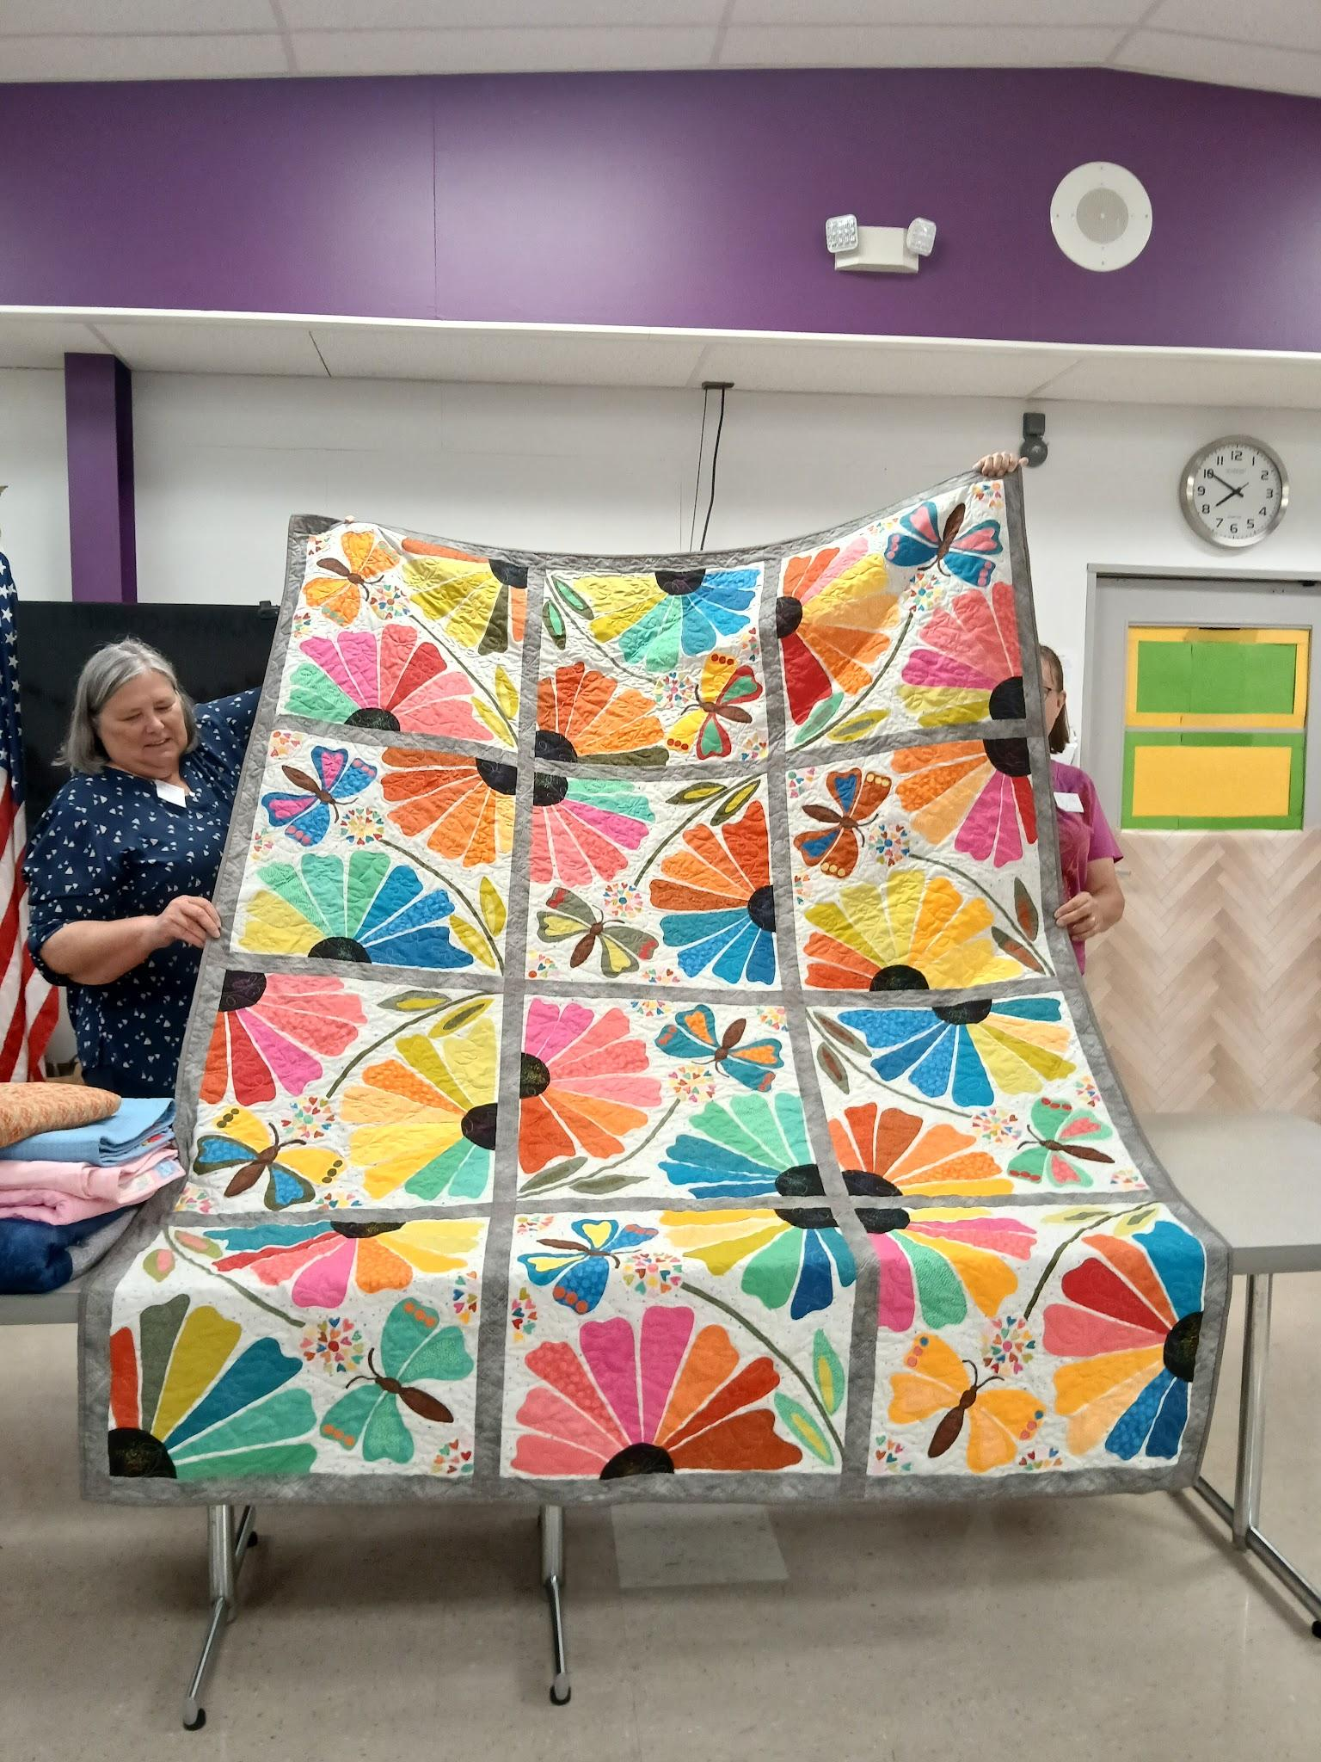

**2025 Raffle Quilt pictured right.**

**Quilt Show General Info:**

Keep up to date by visiting the [Guild Website](http://www.patchoflakeshore.com).

A webpage containing information for members about the quilt show is up.

[www.patchoflakeshore.com/qsmemberinfo](https://www.patchoflakeshore.com/qsmemberinfo)

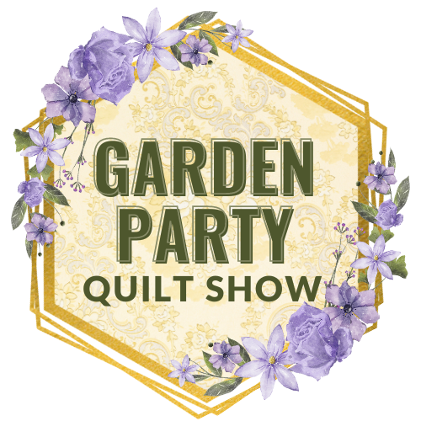

This page includes:

Quilt Registration Form

How to Add a Hanging Sleeve

Quilt Challenge Requirements

Quilt Committee Descriptions

If you have Quilt Show info you would like included (in the newsletter or website), send me an email at [naomianderson428@gmail.com](mailto:naomianderson428@gmail.com).

* **Props Committee Request**
  + Thanks for the donations so far!
    - Still accepting embroidery hoops and florals, specifically greenery, and white, pink, purple flowers, especially droopy styles.

Thanks - Naomi Anderson

| **☆ ☆ ☆ Quilts for Veterans ☆ ☆ ☆** |
| --- |

Guidelines for Quilts for Veterans.

Making a quilt to donate to a veteran? Please keep the following in mind.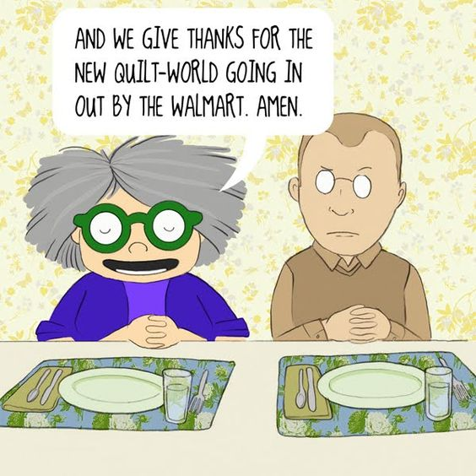

* A Lap Quilt is a preferred size for many.
* Keep your colors patriotic and purposeful. True red, white and blue. Deep colors, not pastels.
* Same goes for the prints themselves. No floral, seasonal or religious.
* Please put a label on your quilt

Your quilt will be truly treasured by a Veteran.

| **? ? ? 2024-2025 Mystery Quilt ? ? ?** |
| --- |

~ Pattern on page 6 ~

~ quantity: make 1 block ~

This year’s mystery quilt features 16 different 10-1/2" blocks, making a quilt that finishes up at 54-1/2" X 54-1/2". There is an additional month for sashing and borders. I began the blocks with 2 yards of background fabric and a whole lot of scraps, so it’s another chance to get out that scrap basket. If you are undecided as to whether you want to join in on the mystery, watch the blocks appear each month and decide then. You are always able to get past blocks on our website.

Remember to bring your completed blocks to the guild for show and tell!

~Chris Bauknecht

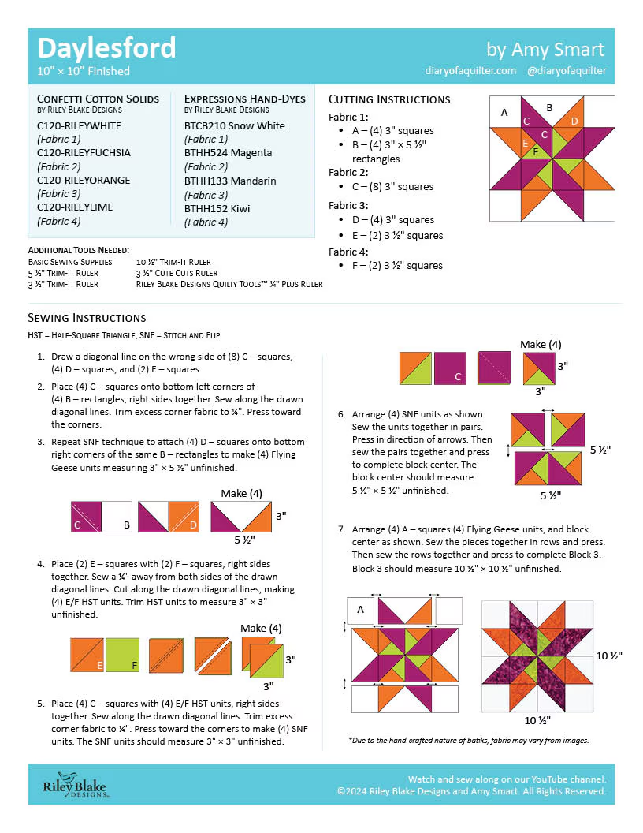

**QUILT ENTRY FORM** - (*one form per quilt*) *updated: 9/10/24* **Due:** March 6, 2025  
 ~Quilt submissions limited to members of the quilt guild.

| **General Info**  Name of person entering quilt _____________________________Phone______________  Name of quilt______________________________________________________________  Who did the quilting_________________________ Hand quilted____ Machine quilted____  Size of quilt: Width______inches X Height______inches  To be judged: No______ Yes______   $7.00 per quilt to be judged (pay with entry form when turned in) | |
| --- | --- |
| **Quilt Category.** *Choose ONE* category that best describes your quilt:  (see category descriptions on page 2) | |
| 1. **Applique -** Hand____ Machine____ 2. **Art** 3. **Challenge** 4. **Embroidered -** Hand___ Machine___ 5. **Group Quilt -** include names:______________________________________________________________________________ 6. **Miscellaneous** quilted item i.e. purse, table runner, garment, wool mats, etc. 7. **Novice** (1-2 years quilting experience) 8. **Youth -** 18 years and under 9. **Quilts for Veterans** | 1. **Traditional pieced**    * Indicate quilting method:      + *Personally* Machine Quilted ___      + *Personally* Hand Quilted ___      + *Professionally* quilted ___    * Indicate size by width:      + Small (*width* up to 50”) ___      + Medium (*width* 50-69”) ___      + Large (*width* over 69”) ___ 2. **2022-23 and 2023-24 Guild Mystery Quilt** |
| **Give a basic feature of the quilt**: ____________________________________________ (i.e. star blocks or scrappy 9-patch. This helps the show volunteers more quickly identify quilts) | |
| **Quilt Description** ***EMAIL your description to Mary H. maryhutch8282@gmail.com***  **Include**:   * your name * the name of the quilt * a paragraph about the quilt (limit 50 words)   + i.e. What’s the story behind the quilt? What inspired you to make the quilt? Name of pattern? If giving to a veteran, who and why? Who quilted it?   *If unable to email description, please clearly write your description on the back of form.* | |
| **Name of person picking up quilt**, if other than person entering:_____________________ | |

**Disclaimer**: By entering my quilt or quilted item into the Patch of Lakeshore Quilt show, I understand that A Patch of Lakeshore Quilters will take every precaution to safeguard my quilts/items, but will not be held responsible for any damage or loss. Photography will be allowed during the show. All entries may be photographed and used at the guild’s discretion.

Print name:_____________________Signature_______________________ Date_______

MAIL ENTRY AND ANY APPLICABLE PAYMENT TO:   
Kathy Guralski, 4609 Ridge Court, Manitowoc, WI 54220

**QUILT ENTRY RULES AND GUIDELINES:**

* A quilt must be quilted through 3 layers (top, batting, backing).
* Pieced, tied quilts are permitted. No whole cloth tied quilts.
* Each quilt/item needs a label attached to the lower left corner as you look at the back of the quilt/item. Labels should include your name and name of the quilt.
* Each item requires a 4” sleeve across the top of the quilt/item for hanging.
* Quilt has not been entered in any Patch of Lakeshore Quilters previous shows.
* Review the quilt show categories (outlined below) and make sure you are choosing the correct category. Fill out the registration form completely or it will be returned for you to complete. The check-in committee reserves the right to re-categorize any quilt that is registered in an incorrect category.
* Quilts must be clean and free of smoke, odor and pet hair. The check-in committee reserves the right to reject any entry that does not comply.
* **Quilt check-in** is Thursday April 3, 2025 at Manitowoc Expo Center from 9am to 6pm for all quilts *except* Judged quilts.
* **Judged quilts** must be turned in *Wednesday*, *April 2, 2025* between 9-10am at Meadow Lanes North, 1540 Johnston Drive, Manitowoc.
* **Quilt check-out** begins Sunday, April 6, 2025 *after* vendors are gone and everything is taken down and cleaned up; not before.

**QUILT CATEGORY DESCRIPTIONS:**

* **Applique**: Hand or Machine. (Applique is easily recognized as the focal point of the quilt.)
* **Art**: entrants own design, produced by one person, with creative thought and without replicating the work of others. May be untraditional in construction and appearance.
* **Challenge**: The challenge quilt must follow the theme of the show: Garden Party. Must use a recognizable amount of any floral fabric in the piece. Must be in quilt form (3 layer sandwich) with an overall measurement not to exceed 100” in perimeter (ex: 25x25x25x25). No kits are allowed.
* **Embroidered**: Hand or Machine. (Embroidery is easily the focal point of the quilt.)
* **Group**: Quilt top is put together by 2 or more people, may include block exchanges, Round Robins or multi-generational quilts. Include names of all participants.
* **Miscellaneous quilted item**: purse, table runner, garment, wool mats, etc
* **Novice**: quilter with 1-2 years of quilting experience
* **Youth**: 18 years and under
* **Quilts for Veterans**: quilt made for a veteran, active or retired. Quilts for Veterans will be presented to selected veterans on Sunday, April 6.
* **Traditional pieced**: Hand or Machine Piecing dominates over other techniques  
   Indicate quilting method: *Personally Machine* or *Hand Quilted by yourself* *Professionally Quilted by someone else*

Indicate quilt width: *Small* (*width* up to 50”), *Med.* (*width* 50-69”), *Large* (*width* over 69”)

* **2022-23 and 2023-24 Guild Mystery Quilt**: Mystery quilt as given by the guild in recent years