**NEWSLETTER**

Volume 21 Issue 03 March 2025

| **Guild Meeting:**  March 13th, **6pm**  ~At Ascend Services  2818 Meadow Lane, MTWC | **Upcoming:**  **Quilt Show Committee Meeting**  March 10, 6pm - Quilt Shop of TR  **National Quilting Day**  March 15-16, Ascend Services  See below for details  **Camp Quilt**  March 21-23  Info: page 9 Form: page 10 |
| --- | --- |
| **Quilt Show Corner - Page 4-7**  **Mystery Quilt - Page 11** | |

**REMINDER: QUILT REGISTRATIONS ARE DUE MARCH 6**

***UPDATE FOR QUILTS BEING JUDGED:***

***BRING TO EXPO CENTER WEDNESDAY APRIL 2 FROM 9 - 11 AM***

| **National Quilting Day** |
| --- |

A Patch of Lakeshore Quilters will be celebrating National Quilting Day with—what else—a sewing day! We will be gathering at Ascend on Saturday, March 15 from 9:00-4:00 for a day of fun, socializing, sewing, demonstrations, a make n take, and door prizes. We have also reserved Ascend for a sewing day on March 16 from 9:00-4:00.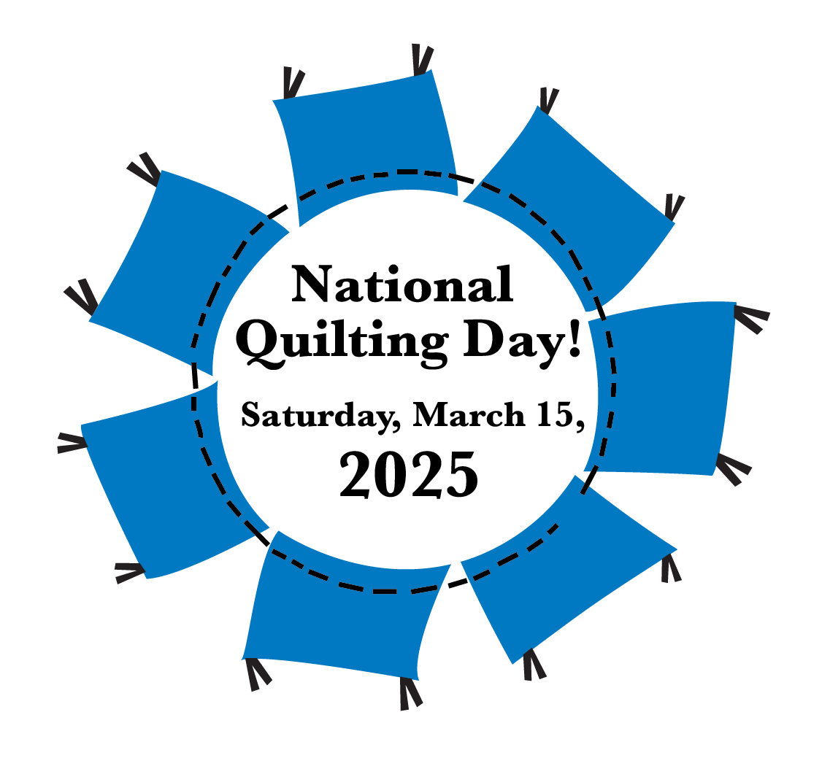

You can sign up for either or both days. All the National Quilting Day activities will take place on Saturday the 15th, however. The cost of each day is $10/day, to cover the cost of Ascend.  
You can sign up at the next meeting or call Mary Ellen Beebe (920) 629-1819 or Cindy Dillman (407) 873-2944, or email mbeebe48@gmail.com.

Plan to bring your lunch and beverage. Desert will be provided. If you have an interest in demoing anything, please contact Mary Ellen or Cindy. You will be able to leave your sewing supplies at Ascend if you are coming both days. So, find a project to work on, and sign up!

| **~ Feb 13th Guild Meeting Minutes ~** |
| --- |

* **Call to Order**
  + Welcome & Pledge
* **Show & Tell**
  + Ann & Jeanette showed the Fair Quilt
* Speaker was ill
* **Info**
  + Julie Klumpp shared about Quilt Camp, March 21-23
    - Registration form available in the February newsletter
  + National Quilting Day
    - March 15 & 16 at Ascend
  + **Quilt Show Info**
    - Quilt for Vets
      * Add name to the list with Julie K
    - Ann Hall has raffle tickets available
    - Judged quilts must be turned in to the Expo on Wed, April 2 9am-11am
      * Judging will begin at 1
    - Charity Booth is in need of donated handmade items
    - Appraisals will be done on Sunday, April 6
      * $55 for each quilt appraised
    - Workers are needed for:
      * Wed, April 2, 7am to Noon
      * Thurs & Fri, April 3 & 4, from 7am to end of the day.
        + Come as you are available throughout the day
    - Quilt Drop off times: Thursday 9am to 6pm
  + New member introduced
  + Linda Londo has more baskets for raffle items
* **Social Time**
* **More info**
  + March will be crunch time! March 13 is the final meeting before the show
  + Theme for the 2025 Manitowoc County Fair: Rock and Roll
    - Colors: pink, black and royal blue
    - On your computer/smartphone? Click [here](https://manitowoccountywi.gov/departments/expo/manitowoc-county-fair/ladies-day-event/) for the Women’s Day Event info and quilt block entry form.
  + Worksheet for work schedule passed around
  + Quilt Walk - some members are putting up quilts at specific businesses. If you give Ellen L a quilt, make sure your name is on it.
  + Peggy V. did a presentation on quilt labels. Labels need to be attached on the bottom left hand corner.

| **~ Feb 13th Guild Meeting Minutes ~** |
| --- |

* + - Label Info:
      * Name of Quilt
      * Name of Quilter
      * If quilted by someone else, include their name as well
      * Designer or Pattern Name
      * City Made in
      * Year Made
    - Label Making Techniques
      * Hand Written
        + Use permanent ink pen, for example sharpie fine point
      * On a computer
        + Use printable fabric sheets
      * Use embroidery machine
  + Table Runners should have the hanging sleeve attached to the short side
* Meeting Adjourned

Submitted by Mary Hutchison

| **Shared with the guild** |
| --- |

**Lakeside Quilters Spring Fling Quilt Show**  [OshkoshQuilters.org](http://oshkoshquilters.org)

FREE ADMISSION -- FREE PARKING

Saturday, March 29th, 2025; 9am to 4pm

Lourdes Academy, 110 N Sawyer St, Door 12, Oshkosh, WI

Quilts, Vendors, Raffle, Scissor sharpening, Demos and more

~Quilt submissions are open to all. <https://forms.gle/R9mhz3T3g1ASd5BP8>

| **Flyers, Mini Posters and Yard Signs** |
| --- |



I(Naomi) will be bringing the flyers, posters and yard signs to the committee meeting and guild meeting.

I will also be at the library on Thursday, March 6 from 3 to 5pm if anyone wants to pick some up sooner.

| **⚘ ⚘ ⚘ 2025 Quilt Show Corner ⚘ ⚘ ⚘** |
| --- |

| **Quilt Show Set Up**: April 3 & 4  **Quilt Show Open**: April 5 & 6  Event at the MTWC Expo Center | **2025 Quilt Show Chairs:**  Julie Klumpp & Kathy Guralski |
| --- | --- |
| **Theme:** Garden Party | **Featured Quilter:** Mary Hutchison |

**Quilt Show General Info:**

[www.patchoflakeshore.com/qsmemberinfo](https://www.patchoflakeshore.com/qsmemberinfo)

If you have Quilt Show info you would like included (in the newsletter or website) send info to [naomianderson428@gmail.com](mailto:naomianderson428@gmail.com)

| **Set up and Show Schedule** |
| --- |

The below schedule is meant to give members an overview of the Quilt Show weekend. **Times and details are subject to change/correction.**

**Wednesday, April 2nd**

*9 am to 10 am* – **Judged quilts**\* delivered to **Manitowoc Expo Center**. If you are not available during this time, arrange with another member to drop off your quilt/s for you. *Have quilts folded with the label exposed.

**Thursday, April 3rd**

*9 am to 6:00 pm* – Check in quilts.* Quilts must be brought in today; labeled and with a hanging sleeve. *Have quilts folded with the label exposed.

*10 am to 6:30 pm* – Deliver themed baskets and handmade items for sale in the charity booth. Items will also be accepted on Friday.

*12 Noon to 6:45 pm* – Deliver gift boutique items.

*Tasks throughout the day 7 am to evening* - Tables set up to receive quilts, poles and bases assembled (muscles and tools needed!), floor taped for layout, pipes and curtains prepped/put up, and general prep work in the kitchen.

***Remaining raffle tickets and money MUST be returned before the show opens.***

| **Set up and Show Schedule continued** |
| --- |

**Friday, April 4th**

*7 am to Finish* – Quilt show set up. Everyone helps. If you can only help for a couple hours, please come; every little bit of help is needed.

*Tasks throughout the day* continue - Poles with bases placed, pipes and curtains prepped/put up, quilts hung up, tables moved to vendor areas, and other fine tuning.

Individual committees set up their areas.

*9:00 am to 12 Noon* – Deliver gift boutique items.

*9:00 am to 11:00 am* - Drop off Friday food donations.

*12 Noon* – Take Tylenol as our feet will hurt.

*4 pm -* Vendors start coming to set up

Any ladder-climbing, able body persons are welcome at any time to hang lights and/or quilts.

***Remaining raffle tickets and money MUST be returned before the show opens.***

**Saturday, April 5th & Sunday April 6th – 9:00 am – 3:00 pm - Show Open!**

Remember each guild member is asked to work two 3-hour shifts during the run of the show. If you still need to volunteer or have questions about when you work please call Ellen Lewellen.

**Saturday, April 5th**

*9 am* – Drop off Saturday and Sunday bars

*9 am to 3 pm* - Quilt Show open

**Sunday, April 6th**

*9 am to 3 pm* - Quilt Show open

*1 pm* – Quilts for Veterans presentation

*3 pm* – Show closes. Pick name for raffle quilt winner. Good luck everyone.

*3 pm* – Vendor pack up. PLQ members help as needed.

*4 pm* – Once ALL vendors are out, everyone helps take down quilts. After all quilts are down and the display area is cleared and packed, quilts will be returned to their owners. This takes about a couple hours. Many hands make light work, but we also want to be safe when moving the pipes and poles.

*6:30 pm* – Home with our feet up and enjoying our favorite beverage.

| **⚘ ⚘ ⚘ 2025 Quilt Show Corner Continued ⚘ ⚘ ⚘** |
| --- |

* **Gift Boutique**

Just a few last minute reminders for those members selling their homemade items in the Gift Boutique:

Since Easter is just around the corner, you may want to make some “Eastery” items.

If you can display your items in a container, i.e. basket, bowl, decorative box - please do so, making sure your name is on the bottom of the container.

An inventory list and sample price tag was published in the February newsletter, and is also available on the website. Please use this uniform inventory list, as it will be much easier to keep an accurate record of all the sales.

We’d like to encourage the new members and also those members having items in the Gift Boutique to sign up for a shift. Or, at least try to sell on Saturday or Sunday, even if for a half hour or so.

If any member is also donating an identical or similar item to the charity booth, please price the donated item the same, so that the Gift Boutique and Charity Booth are not competing with each other.

A disclaimer must be signed when your items are dropped off.

Drop off times are as follows:

Thurs, April 3, Noon to 6:30pm OR Fri, April 4, 9am to Noon

If you have any questions, please contact us!

Mary Kay Burish [mkburish@baytitle.com](mailto:mkburish@baytitle.com) 682-7006   
 or Bonnie Loeh [bnloeh@gmail.com](mailto:bnloeh@gmail.com) 682-3259

**Ideas for Gift Boutique (or Charity Booth) Items**

Purses

Bags - shoulder/zippered/Tote/Beach

Drawstring bags

Sandwich-snack bags / Potato Bags

Clothes pin bags

Lingerie bags

Embroidered flour sack towels

Towels with crochet tops

Cotton dish cloths / Wash cloths

Microwave bowls

Hot pads/potholders - pieced/applique

Dyed fabrics, socks, t-shirts, sweaters

Scarves - various fabrics

Fabric yo-yo pins

Doll clothes

Pillow cases (consider 2 matching)

Crochet doilies and head bands

knit/crochet scarves

Crochet blanket / throws

Wallhangings - various sized/paper pieced

Table runners - various sizes and shapes

Coasters - various styles and sizes

Fabric baskets

Candle mats

Thread catchers / Pin cushions

Abstract paintings / bookmarks

Key rings / luggage tags

Wooden folding camping/patio table

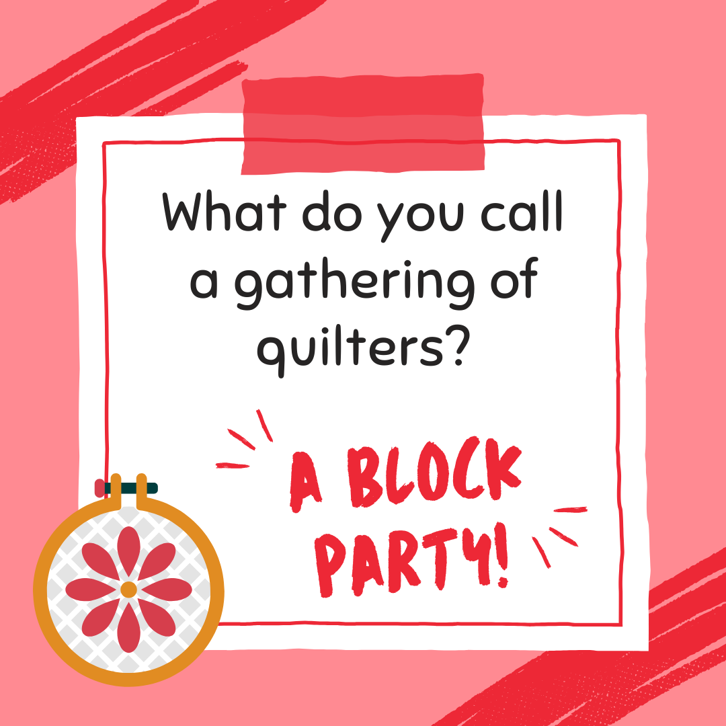



| **? ? ? 2024-2025 Mystery Quilt ? ? ?** |
| --- |

~ Pattern on page 8 ~ quantity: make 1 block ~

Check out this starry block!

Join the Mystery Quilt anytime. Past newsletters, starting with Sept. 2024, contain all the blocks that have previously been revealed.

