**NEWSLETTER**

Volume 21 Issue 02 February 2025

| **Guild Meeting:**  Feb 13th, **6pm**  ~At Ascend Services  2818 Meadow Lane, MTWC | **Upcoming:**  **Quilt Show Committee Meeting**  Feb. 10, 6pm -Quilt Shop of Two Rivers  **National Quilting Day**  March 15-16, Ascend Services  See below for details  **Camp Quilt**  March 21-23  Info: page 9 Form: page 10 |
| --- | --- |
| **Quilt Show Corner - Page 4-7**  **Mystery Quilt - Page 11** | |

Hey quilting friends! There is a lot of info packed into this newsletter. Be sure to read up on a **General Overview of the Quilt Show Schedule** (pages 5 & 6), take advantage of our guild events (Camp Quilt page 9-10; National Quilting Day below), and see what other area guilds have shared with us (page 6).

| **National Quilting Day** |
| --- |

A Patch of Lakeshore Quilters will be celebrating National Quilting Day with—what else—a sewing day! We will be gathering at Ascend on Saturday, March 15 from 9:00-4:00 for a day of fun, socializing, sewing, demonstrations, a make n take, and door prizes. We have also reserved Ascend for a sewing day on March 16 from 9:00-4:00.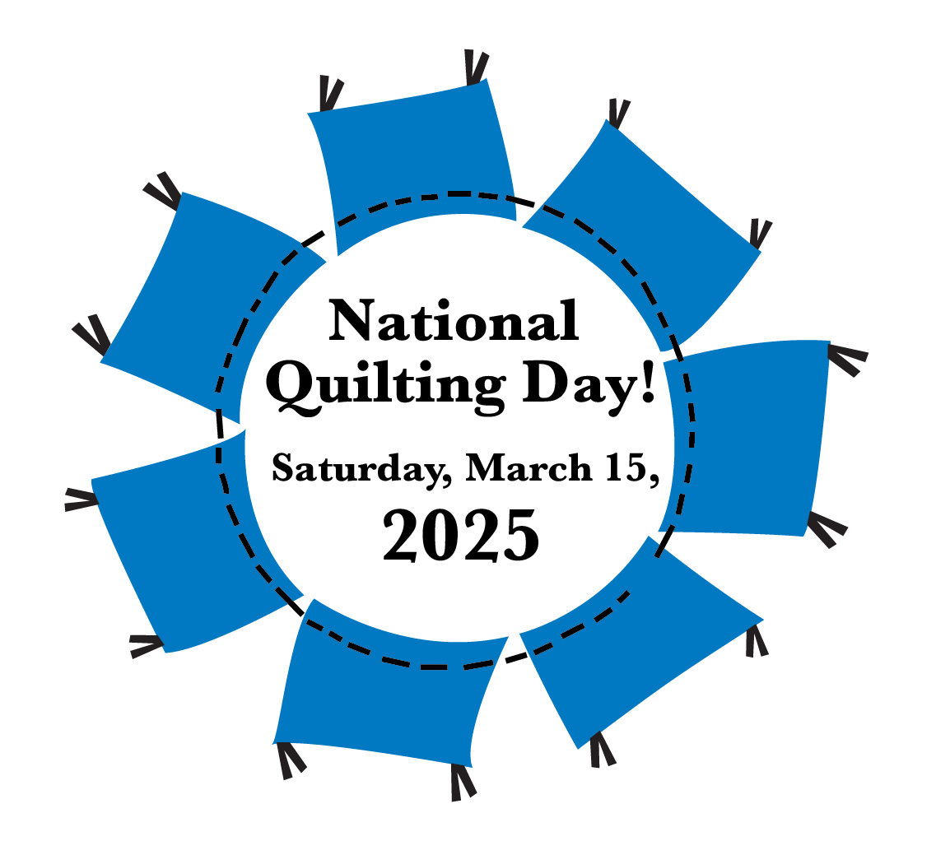

You can sign up for either or both days. All the National Quilting Day activities will take place on Saturday the 15th, however. The cost of each day is $10/day, to cover the cost of Ascend.  
You can sign up at the next meeting or call Mary Ellen Beebe (920) 629-1819 or Cindy Dillman (407) 873-2944, or email mbeebe48@gmail.com.

Plan to bring your lunch and beverage. Desert will be provided. If you have an interest in demoing, anything, please contact Mary Ellen or Cindy. You will be able to leave your sewing supplies at Ascend if you are coming both days. So, find a project to work on, and sign up!

| **~ Jan 9th Guild Meeting Minutes ~** |
| --- |

* **Call to Order**
  + Welcome & Pledge
* **Show & Tell**
* **Business Meeting**
  + Board Meeting on January 6 was productive
    - Discussed spring plans and budget
    - Contact any Board Member with questions. List of current board members is included in the front of the guild directory booklet.
  + Tip Jar - submit your tips or questions to the tip jar!
  + Secretary and Treasurer Report
    - Don’t forget to get your receipts to treasurer Mary Ellen Beebe
  + Do you have editing skills?
    - Looking for someone to update our Guild History info for the website. Naomi will be responsible for getting the new info onto the website, we need someone who will help update our history, streamline it, and include the various charities we support.
    - Contact Ellen Lewellen if interested
  + **Quilt Show**
    - Work Schedule is coming soon!
      * The work schedule is for the days of the actual quilt show. All members are asked to volunteer for 2 time slots.
    - [Painting Pathways](https://paintingpathways.org/) is the charity that will be receiving funds from our sales in the Charity Booth at the quilt show.
    - Registration for Quilts is open; see website for form.
      * Due date is March 6. Quilts do not need to be completed before you register them; they just need to be “complete-able” by the quilt show.
    - **Judged Quilts**
      * Members are all encouraged to take advantage of this opportunity. More info on having a quilt judged will be in the newsletter.
    - **Quilt Walk** - quilts needed to display in area shop windows to help promote the quilt show.
      * If you have a small quilt or wall hanging that can be used or know a shop that would be willing to display a quilt, be in contact with Ellen Lewellen.
  + **Sew Days**
    - In celebration of National Quilting Day, we will be having open sew time available at Ascend.
      * Committee could use one more member. Contact Mary Ellen Beebe or Cindy Dillman to help!
      * Do you have a quilting topic or skill you would like to learn about OR would like to share with the group? We like to have a few 10-15 minute demonstrations to share with the group during the sew day.
    - March 15 & 16, 9am to 4pm both days
    - $10 per person, per day to cover cost of facility rental
    - BYO lunch, sewing machine and project supplies
      * Irons, ironing boards, and cutting mats will be available
* Quilt Sleeve Demonstration
  + Peggy V shared two methods for attaching sleeves to your quilt (a requirement for the quilt show).
    - A method for Temporary Quilt and Permanent Sleeves was shown.
      * I (Naomi) will attempt to add a basic description of her method to the website as I have time.
    - We do have a tutorial video available on the website.
* **Program**
  + Quilt Show Props
    - Members were tasked with helping create items for the props to be used at the quilt show.
      * Thank you to everyone who donated lacey items, embroidery hoops, and twisted papers.
* Submitted by Naomi Anderson

| **☆ ☆ ☆ Quilts for Veterans ☆ ☆ ☆** |
| --- |

After the great success of the **Quilts for Veterans** during the 2023 Quilt Show, it was decided to continue this quilt show also. Quilts can be made with a specific vet in mind, or can be made as a donation and will be given to an area vet.

*Making a quilt to donate to a veteran? Please keep the following in mind.*

* A Lap Quilt is a preferred size for many.
  + Keep your colors patriotic and purposeful.   
     True red, white and blue. Deep, saturated colors, not pastels.
  + Same goes for the prints themselves. No floral, seasonal or religious.
* Please put a label on your quilt

Your quilt will be truly treasured by a Veteran.

| **⚘ ⚘ ⚘ 2025 Quilt Show Corner ⚘ ⚘ ⚘** |
| --- |

| **Quilt Show Set Up**: April 3 & 4  **Quilt Show Open**: April 5 & 6  Event at the MTWC Expo Center | **2025 Quilt Show Chairs:**  Julie Klumpp & Kathy Guralski |
| --- | --- |
| **Theme:** Garden Party | **Featured Quilter:** Mary Hutchison |

**Quilt Show General Info:**

[www.patchoflakeshore.com/qsmemberinfo](https://www.patchoflakeshore.com/qsmemberinfo)

If you have Quilt Show info you would like included (in the newsletter or website) send info to [naomianderson428@gmail.com](mailto:naomianderson428@gmail.com)

| ***Should I get my quilt judged?*** |
| --- |

~from an online article by Frances Arnold of Frances Quilts

[francesquilts.com/2022/10/25/should-my-quilt-be-judged/](http://francesquilts.com/2022/10/25/should-my-quilt-be-judged/)

Many people are nervous about having their quilts judged. They may be worried that their work is not “good enough” or they may not be happy having someone else tell them what is wrong with their piece. Although these are completely understandable, I would like to encourage you to enter your quilts in the upcoming show AND to have them undergo the judging process!

When a judge looks at a quilt, she is an independent, un-biased individual who is looking at your quilt with the idea of ranking your quilt against the others in the category, but also with the idea of giving helpful comments that can move you further along in your quilting career.

In almost every case, the judge’s first comment is about something good in your quilt. It may be your design, your choice of colors, or the subject matter of the quilt.

She will then start looking at more detail, assessing the skill level that you have brought to your creation. Yes, she may say something that you do not like or agree with, but in most cases, she will give feedback that you can use to make a better quilt the next time.

My suggestion to each of you is that you make the very best quilt that you can make (knowing that your skill is slowly improving) and submit them proudly for judging. Remember that we all started out slow…even the judge!

| **Set up and Show Schedule** |
| --- |

The below schedule is meant to give members an overview of the Quilt Show weekend. **Times and details are subject to change/correction.**

**Wednesday, April 2nd**

*9 am to 10 am* – Judged quilts* delivered to Meadow Lanes North (1540 Johnston Dr., Manitowoc). If you are not available during this time, arrange with another member to drop off your quilt/s for you.

*Have quilts folded with the label exposed.

**Thursday, April 3rd**

*9 am to 6:00 pm* – Check in quilts.* Quilts must be brought in today; labeled and with a hanging sleeve.

*Have quilts folded with the label exposed.

*10 am to 6:30 pm* – Deliver themed baskets and handmade items for sale in the charity booth. Items will also be accepted on Friday.

*12 Noon to 6:45 pm* – Deliver gift boutique items.

*(??)6:45 pm* – Guild meeting at Expo Center (??)

*Tasks throughout the day* - Tables set up to receive quilts, poles and bases assembled (muscles and tools needed!), floor taped for layout, pipes and curtains prepped/put up, and general prep work in the kitchen.

***Remaining raffle tickets and money MUST be returned before the show opens.***

**Friday, April 4th**

*8 am to Finish* – Quilt show set up. Everyone helps. If you can only help for a couple hours, please come; every little bit of help is needed.

*Tasks throughout the day* continue - Poles with bases placed, pipes and curtains prepped/put up, quilts hung up, tables moved to vendor areas, and other fine tuning.

Individual committees set up their areas.

*9:00 am to 12 Noon* – Deliver gift boutique items.

*9:00 am to 11:00 am* - Drop off Friday food donations.

*12 Noon* – Take Tylenol as our feet will hurt.

*4 pm -* Vendors start coming to set up

Any ladder-climbing, able body persons are welcome at any time to hang lights and/or quilts.

***Remaining raffle tickets and money MUST be returned before the show opens.***

| **Set up and Show Schedule continued** |
| --- |

**Saturday, April 5th & Sunday April 6th – 9:00 am – 3:00 pm - Show Open!**

Remember each guild member is asked to work two 3-hour shifts during the run of the show. If you still need to volunteer or have questions about when you work please call Ellen Lewellen.

The work schedule will be posted outside the kitchen during the show and at the Thursday Guild meeting.

**Saturday, April 5th**

*9 am* – Drop off Saturday and Sunday bars

*9 am to 3 pm* - Quilt Show open

**Sunday, April 6th**

*9 am to 3 pm* - Quilt Show open

*1 pm* – Quilts for Veterans presentation

*3 pm* – Show closes. Pick name for raffle quilt winner. Good luck everyone.

*3 pm* – Vendor pack up. PLQ members help as needed.

*4 pm* – Once ALL vendors are out, everyone help take down quilts. After all quilts are down and display area is cleared and packed, quilts will be returned to their owners. This takes about a couple hours. Many hands make light work, but we also want to be safe when moving the pipes and poles.

*6:30 pm* – Home with our feet up and enjoying our favorite beverage.

| **Shared with the guild** |
| --- |

**The Wisconsin Museum of Quilts & Fiber Arts** is holding their 5th annual Winter Quilt Show on February 8 from 9:00 am to 4:00 pm at the Washington County Fairgrounds in West Bend.

Admission: $10 Quilts, 40+ Vendors, Lectures, Door Prizes, and more!

<https://www.wiquiltmuseum.com/information-winter-quilt-show>

**Lakeside Quilters Spring Fling Quilt Show**  [OshkoshQuilters.org](http://oshkoshquilters.org)

FREE ADMISSION -- FREE PARKING

Saturday, March 29th, 2025; 9am to 4pm

Lourdes Academy, 110 N Sawyer St, Door 12, Oshkosh, WI

Quilts, Vendors, Raffle, Scissor sharpening, Demos and more

~Quilt submissions are open to all. <https://forms.gle/R9mhz3T3g1ASd5BP8>

| **⚘ ⚘ ⚘ 2025 Quilt Show Corner Continued ⚘ ⚘ ⚘** |
| --- |

* **Gift Boutique**
  + For those members, especially our newest members, wanting to sell their wonderful creations in the Gift Boutique, any handmade items made by you are welcome. Here’s a chance to showcase your talents and earn a bit of money to support your fabric habit!
  + Any member is limited to display at any one time, a maximum of 12 items in any one of your categories. As sales are made, your supply may be replenished. Any extra items may be stored underneath the tables and should be placed in boxes or plastic bins with your name on it.
  + If you can display your items in a container, i.e., basket, bowl, decorative box – please do so, and put your name on the bottom of the container.
  + The Guild retains 10% of all sales.
  + An inventory list and sample price tag will be published in a future newsletter. We will also have them at upcoming meetings. We want you to use this uniform inventory list, as it will be much easier to keep an accurate record of all the sales.
  + As to the price tags, Walmart has a box of 100 strung marking tags, by Avery, 1 3/4” x 1 3/32”, No. 6732.
  + Please number your items consecutively.
  + Tag should include item number, price and member’s last name.
  + Each and every item must have a price tag attached to it with a safety pin. Please set your pricing at full dollar or half-dollar amounts for ease in making change.
  + Anyone still wishing to donate gently used gift bags can bring them to our meetings. We will donate the tissue paper.
  + We would like to have three people on each shift. Two at the checkout and one to help the customers by walking around and keeping an eye out for anyone wanting an item and “forgetting” to pay for it.
  + You, or the person dropping off your items, will be asked to sign a disclaimer. The drop-off dates and times will be announced later.
  + You will receive your money in the form of a check at a future guild meeting or in the mail.
  + If you have any questions, please contact  
    Mary Kay Burish [mkburish@baytitle.com](mailto:mkburish@baytitle.com) 682-7006   
    or Bonnie Loeh [bnloeh@gmail.com](mailto:bnloeh@gmail.com) 682-3259

Last Name: ______________________________

*A Patch of Lakeshore Quilters 2025 Show - April 5 & 6*

**GIFT BOUTIQUE INVENTORY LIST**

Name: ____________________________________________________

* Number items consecutively
* Each item must have its own individual number
* Price in half or full dollar amounts
* Attach price tags (Avery 6732) with safety pins to your items

| **NO.** | **PRODUCT** | **DESCRIPTION/SIZE** | **PRICE** |
| --- | --- | --- | --- |
|  |  |  |  |
|  |  |  |  |
|  |  |  |  |
|  |  |  |  |
|  |  |  |  |
|  |  |  |  |
|  |  |  |  |
|  |  |  |  |
|  |  |  |  |
|  |  |  |  |
|  |  |  |  |
|  |  |  |  |
|  |  |  |  |
|  |  |  |  |
|  |  |  |  |
|  |  |  |  |
|  |  |  |  |
|  |  |  |  |
|  |  |  |  |
|  |  |  |  |
|  |  |  |  |
|  |  |  |  |
|  |  |  |  |

page __ of __

| **🏕 Camp Quilt - March 21-23 🏕** |
| --- |

* **Dates**: March 21-23
* **Location**: Camp Tapawingo, 915 W. Tapawingo Road, Mishicot
* Three days of sewing/quilting/preparing for projects that you bring/sharing ideas/conversations/eating with fellow quilters. Bring your projects, sewing machine and whatever you need to work on your projects. Some choose to stay overnight, others go home and return each day.
* **Overnighting?:** Two large bunk rooms, with showers and toilets, are available downstairs. Bring your own bed linens, towels and toiletries.
* **Provided**: Irons (water)/ironing boards/cutting tables/mats provided.
* **Breakfast**: (optional) Friday, March 21 meet at 8:00 am Two Rivers Family Restaurant, 3015 Tannery Road, Two Rivers. Anyone wanting to join us before we go out to camp, you are responsible to pay for your own meal. If you are not meeting for breakfast, camp will open approx. 9:20am.
* **Registration**: form available in newsletter
* **Fees**: Are due at time of registration with checks made out to PLQ.
  + PLQ member- $65.00 for the three days of camp.
  + Non-member- $85.00 (if any opening) for three days of camp.
* **Door prizes**: Anyone at camp who wishes to participate in “BOGO” drawing brings a wrapped ($10.00) gift. Be sure to place your name inside the gift so the person receiving knows you to thank. Put your name on paper and place in drawing container. Drawings occurs throughout the weekend.
* **Meals**:
  + Friday lunch on your own. Supper – pizza provided.
  + Saturday- two meals provided, brunch and supper.
  + Sunday- brunch provided.
  + Beverages provided are milk/coffee/ OJ/water. Any other beverages BYOB. There is an ice machine at camp.
  + There is a sharing table for snacks; bring whatever you choose. You are asked to take any leftovers home with you if there are any.

***If you usually eat breakfast, on Saturday and Sunday you can eat off the sharing table or bring what you want to eat.

**QUILT CAMP REGISTRATION**

March 21-23, 2025

NAME: __________________________________________________________

ADDRESS: _______________________________________________________

PHONE: _________________________________________________________

MEALS: CHECK WHICH YOU WILL BE PRESENT FOR

______ ALL MEALS ______ FRIDAY SUPPER

______ SAT BRUNCH ______ SAT SUPPER

______ SUNDAY BRUNCH

ARE YOU A COFFEE DRINKER? ______YES ______NO

IF YES, HOW MANY CUPS A DAY _____, REGULAR _____, DECAF _____

CAMP PAYMENT: MAKE CHECKS PAYABLE TO PLQ-QUILT CAMP

$65 MEMBERS $85 NON-MEMBERS

MAIL TO: JULIE KLUMPP, 2123 PRIMROSE LANE, MANITOWOC, WI 54220

QUESTIONS: JULIE KLUMPP, 920-860-0485 OR [JAKLUMPP@TM.NET](mailto:JAKLUMPP@TM.NET)

| **? ? ? 2024-2025 Mystery Quilt ? ? ?** |
| --- |

~ Pattern on page 11 ~ quantity: make 1 block ~

Check out this beautiful block!

Join the Mystery Quilt anytime. Past newsletters, starting with Sept. 2024, contain all the blocks that have previously been revealed.

